CHAPTER 4: SOFTWARE DESIGN DESCRIPTION

4.1. Purpose

4.2. Architecture Overview

4.2.1. System Architecture

#### MVC model

Model–view–controller (MVC) is a software architectural pattern for implementing user interfaces on computers. It divides a given application into three interconnected parts. This is done to separate internal representations of information from the ways information is presented to, and accepted from, the user

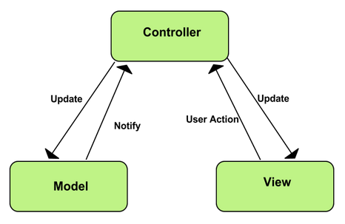

MVC Model

* **Model:** Model represents shape of the data and business logic. It maintains the data of the application. Model objects retrieve and store model state in a database.
* **View:** View is a user interface. View display data using model to the user and also enables them to modify the data.
* **Controller:** Controller handles the user request. Typically, user interact with View, which in-tern raises appropriate URL request, this request will be handled by a controller. The controller renders the appropriate view with the model data as a response.

#### Advantages and disadvantages of MVP model

* **Advantages**
  + **Faster development process:** MVC supports rapid and parallel development. With MVC, one programmer can work on the view while other can work on the controller to create business logic of the web application. The application developed using MVC can be three times faster than application developed using other development patterns.
  + **Ability to provide multiple views:** In the MVC Model, you can create multiple views for a model. Code duplication is very limited in MVC because it separates data and business logic from the display.
  + **Support for asynchronous technique:** MVC also supports asynchronous technique, which helps developers to develop an application that loads very fast.
  + **Modification does not affect the entire model:** Modification does not affect the entire model because model part does not depend on the views part. Therefore, any changes in the Model will not affect the entire architecture.
  + **MVC model returns the data without formatting:** MVC pattern returns data without applying any formatting so the same components can be used and called for use with any interface.
  + **SEO friendly Development platform**: Using this platform, it is very easy to develop SEO-friendly URLs to generate more visits from a specific application.
* **Disadvantages**
  + Increased complexity
  + Inefficiency of data access in view
  + Difficulty of using MVC with modern user interface.
  + Need multiple programmers
  + Knowledge on multiple technologies is required.
  + Developer have knowledge of client side code and html code.

4.3. Component Diagram

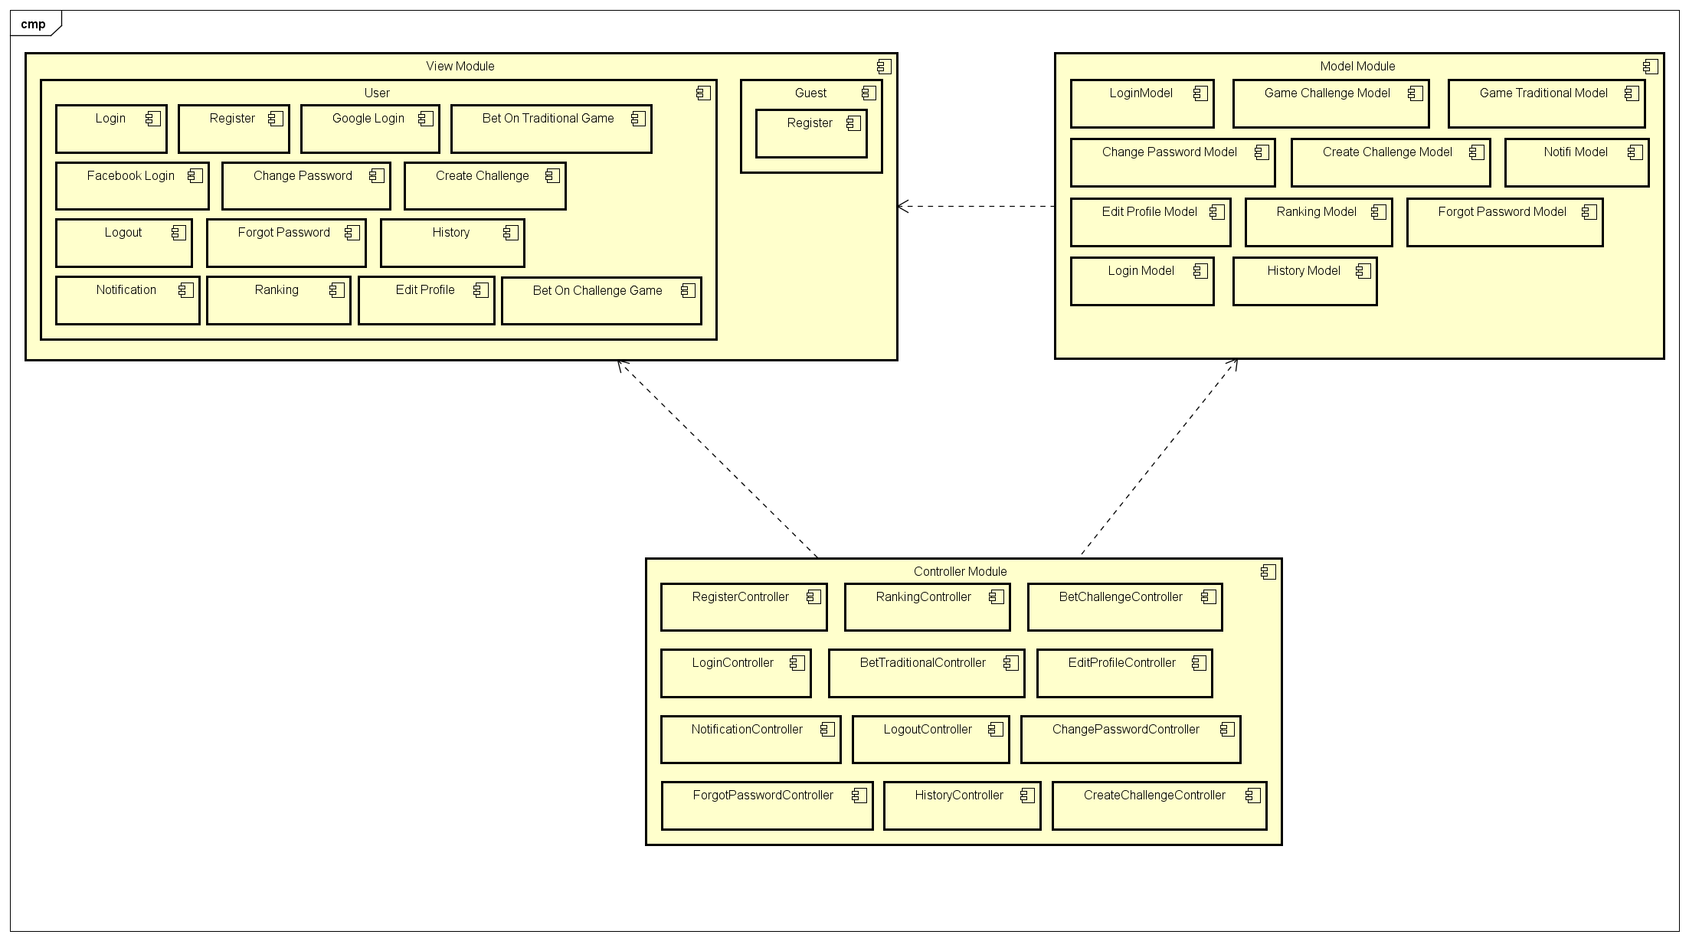

4.4.A. Sequence Diagram

Several sequence diagrams are shown in the following:

4.4.A.1. Register

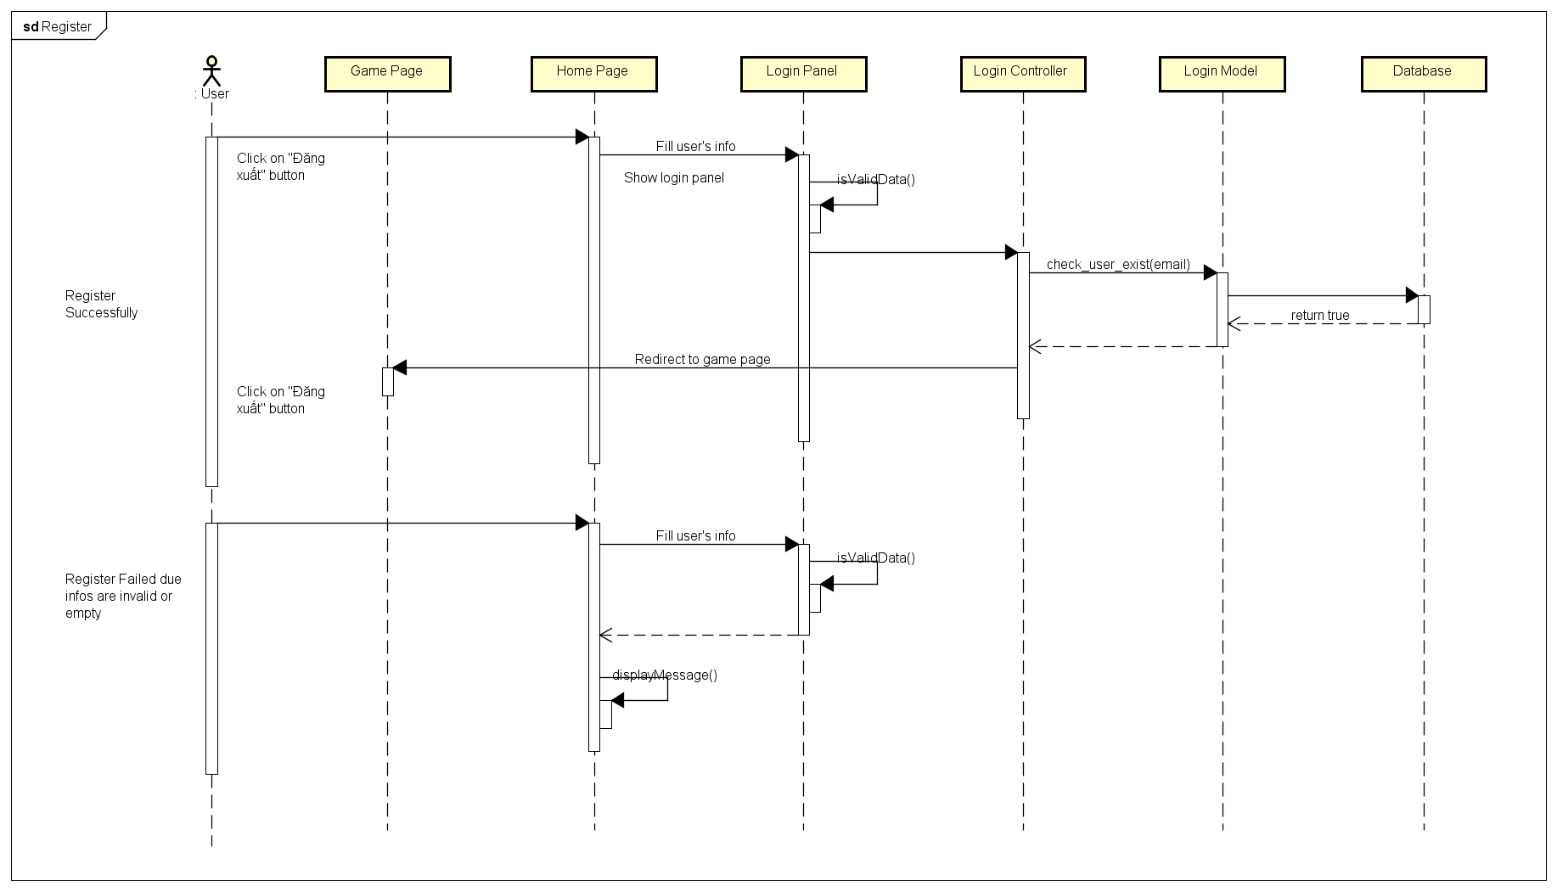

4.4.A.2. Login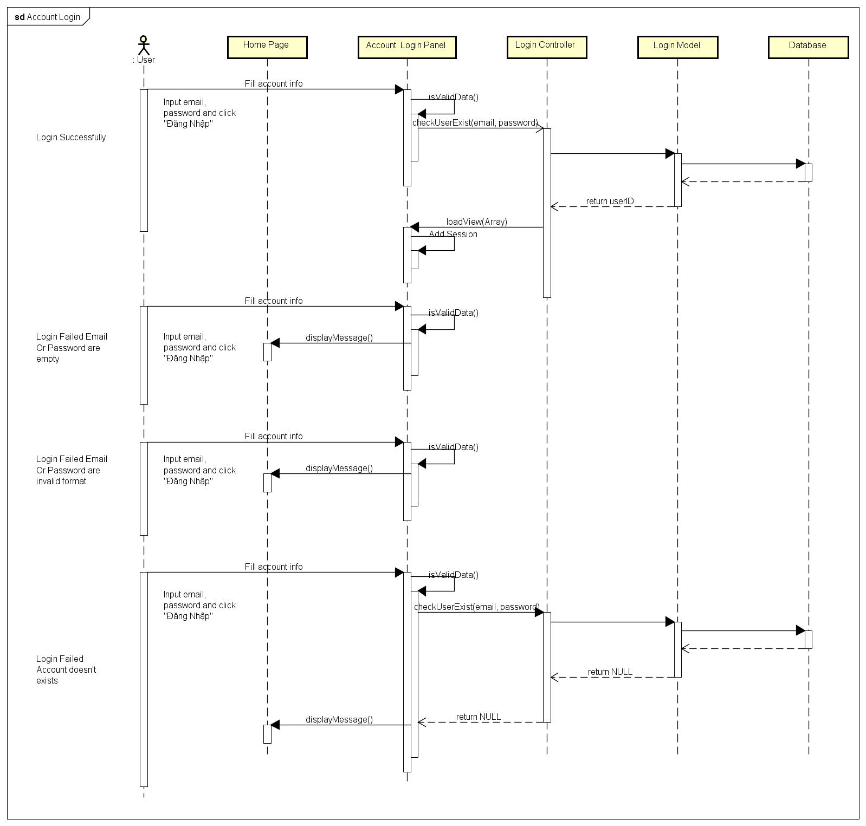

4.4.A.3. Login Using Facebook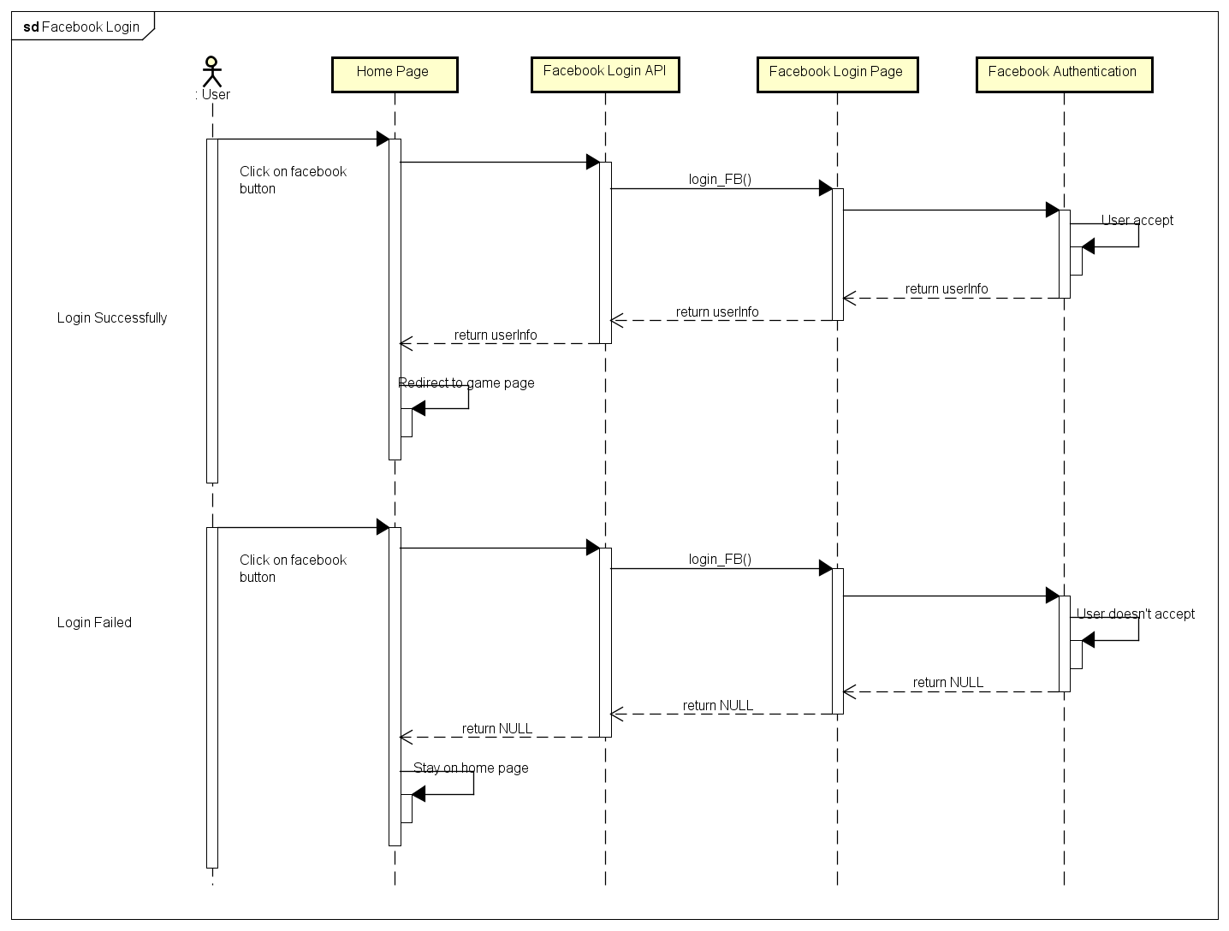

4.4.A.4. Login Using Google Plus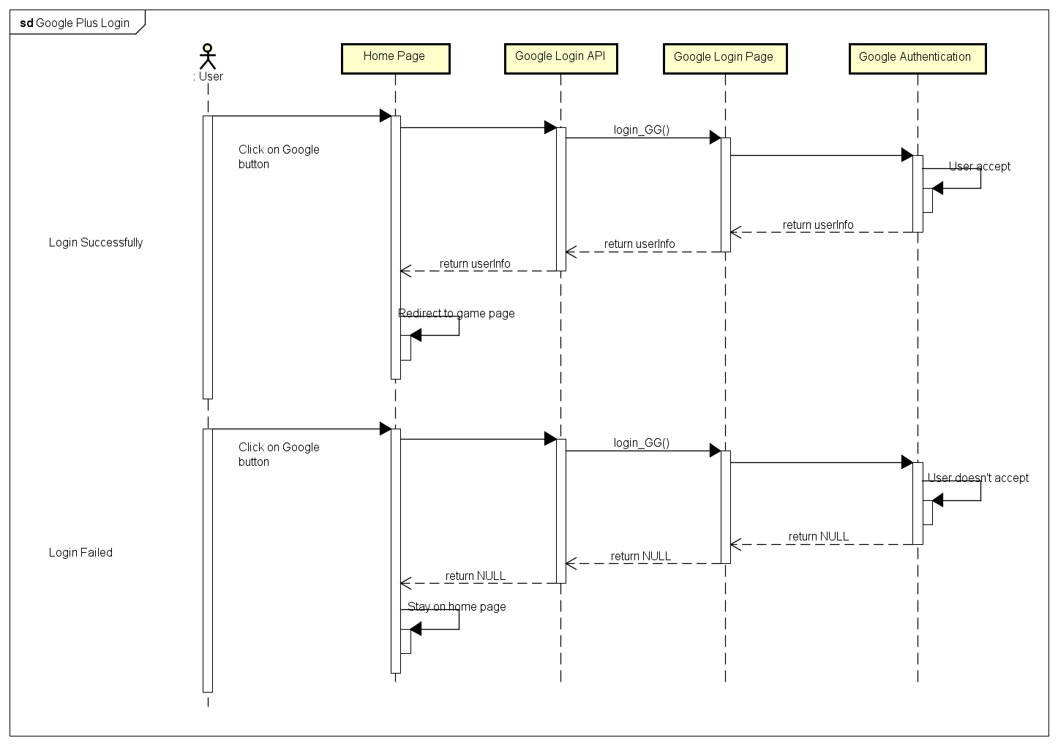

4.4.A.5. Logout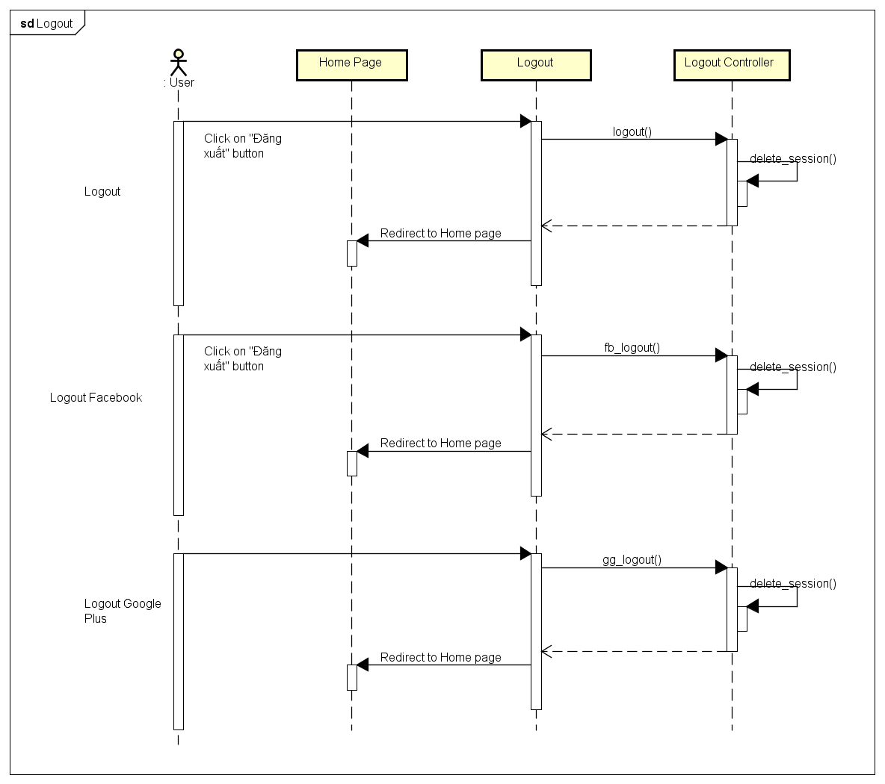

4.4.A.6. Change Password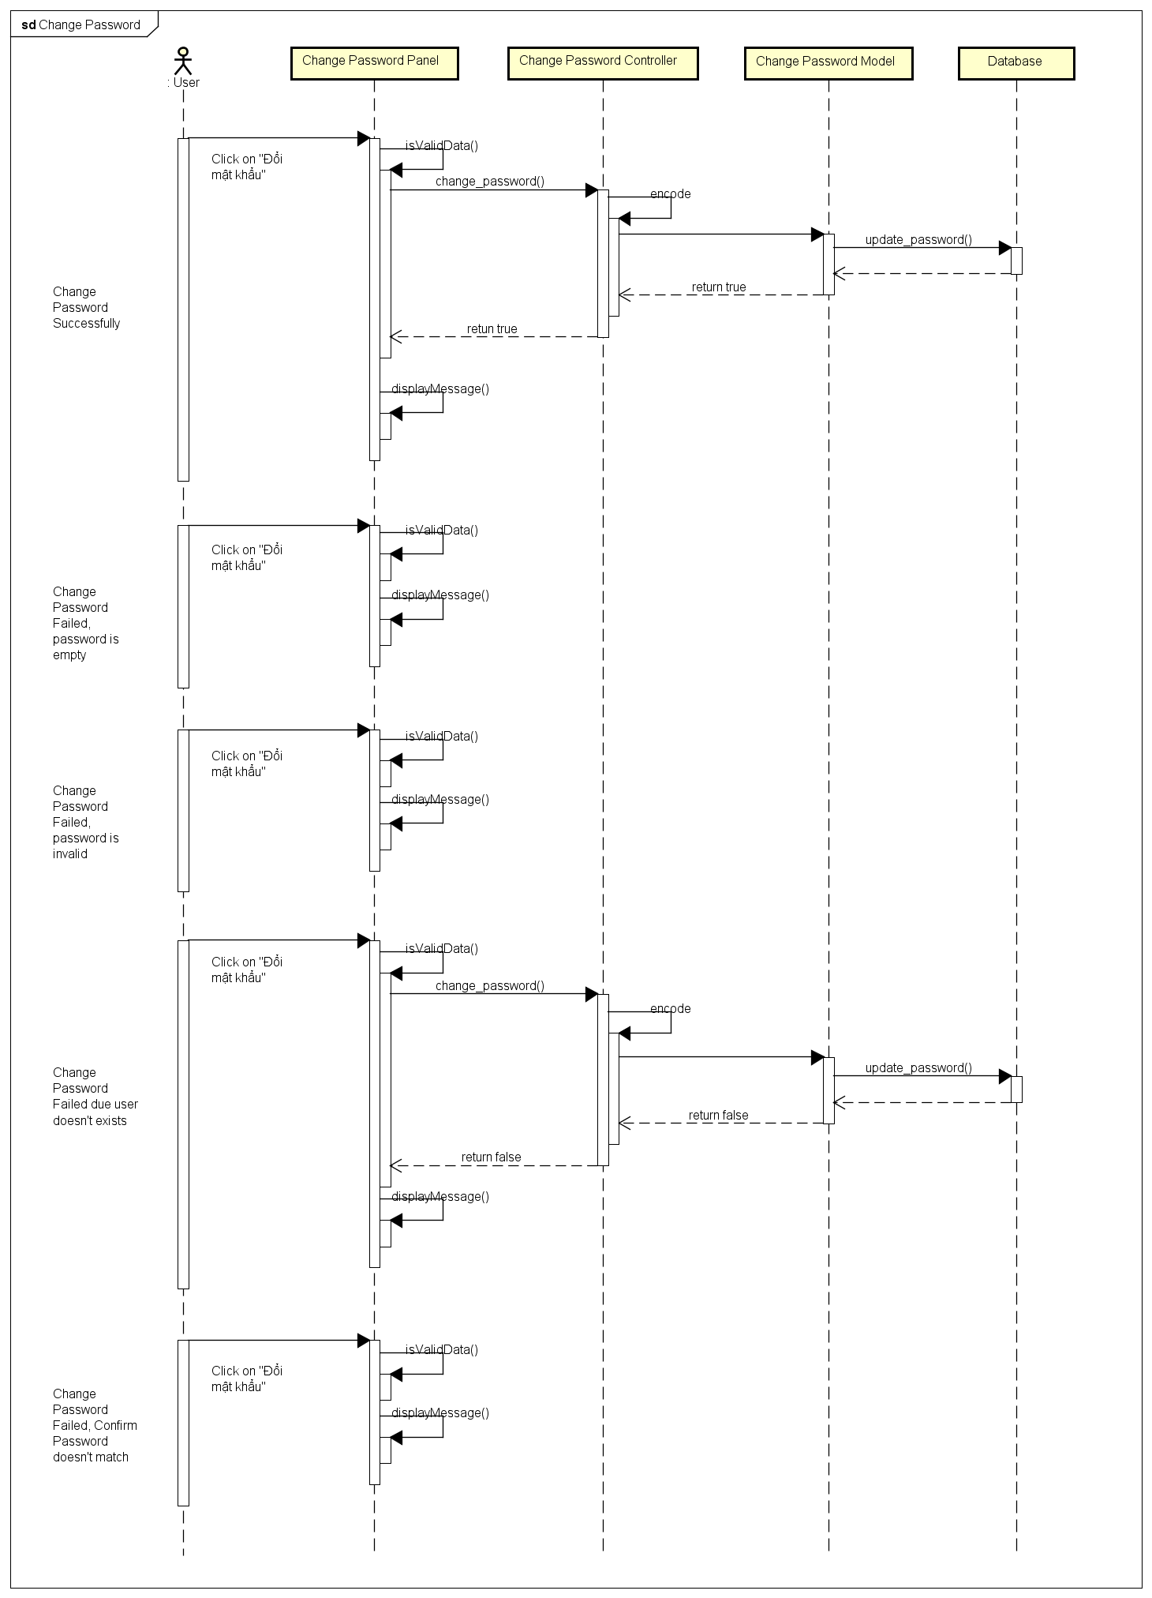

4.4.A.7. Forgot Password

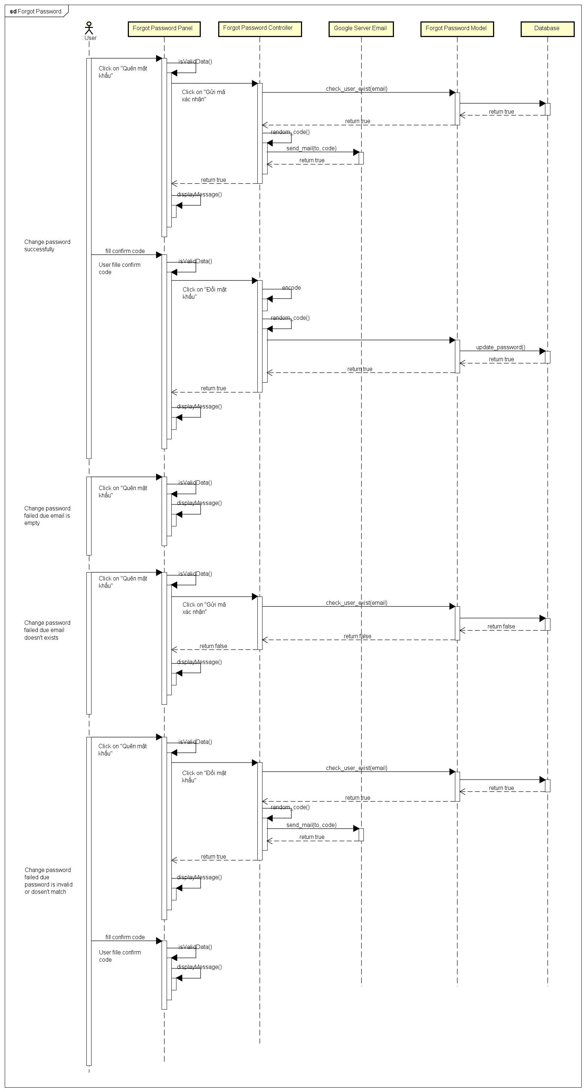

4.4.A.8. Edit Profile

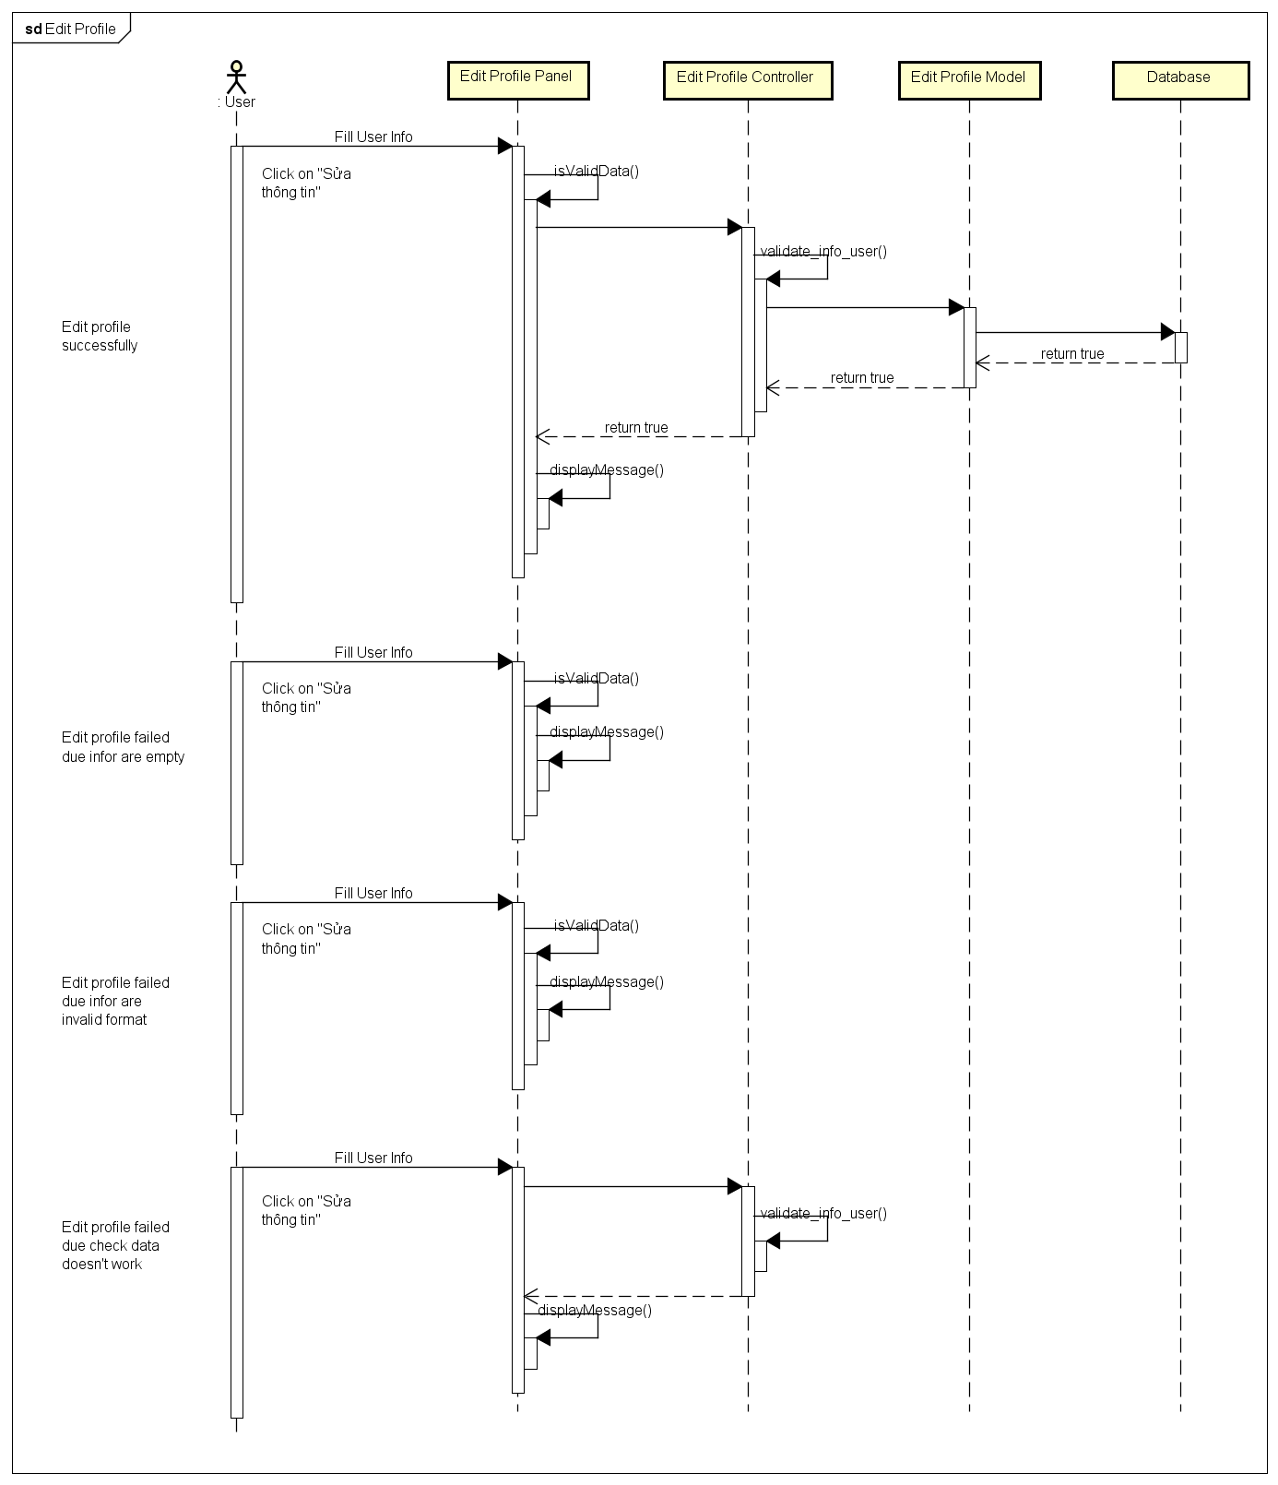

4.4.A.9. History

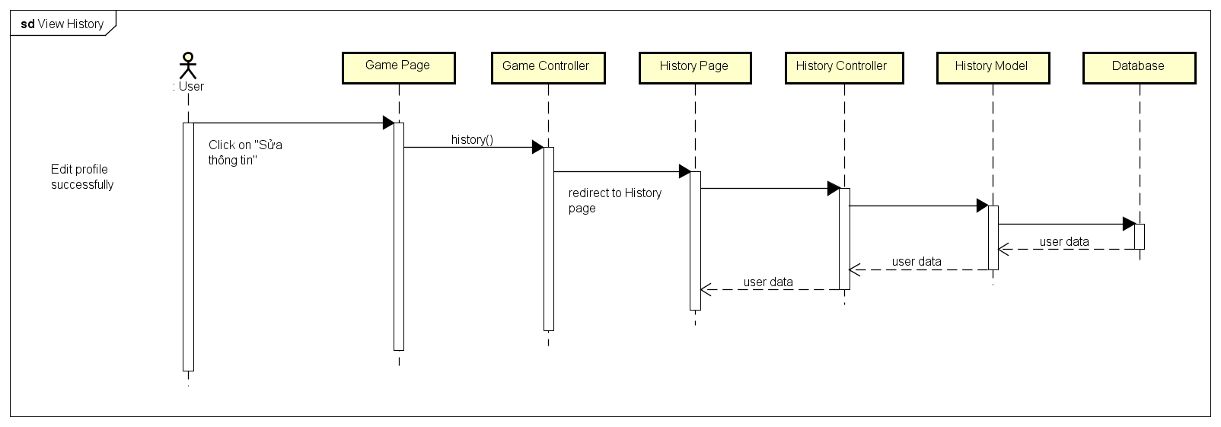

4.4.A.10. Notification

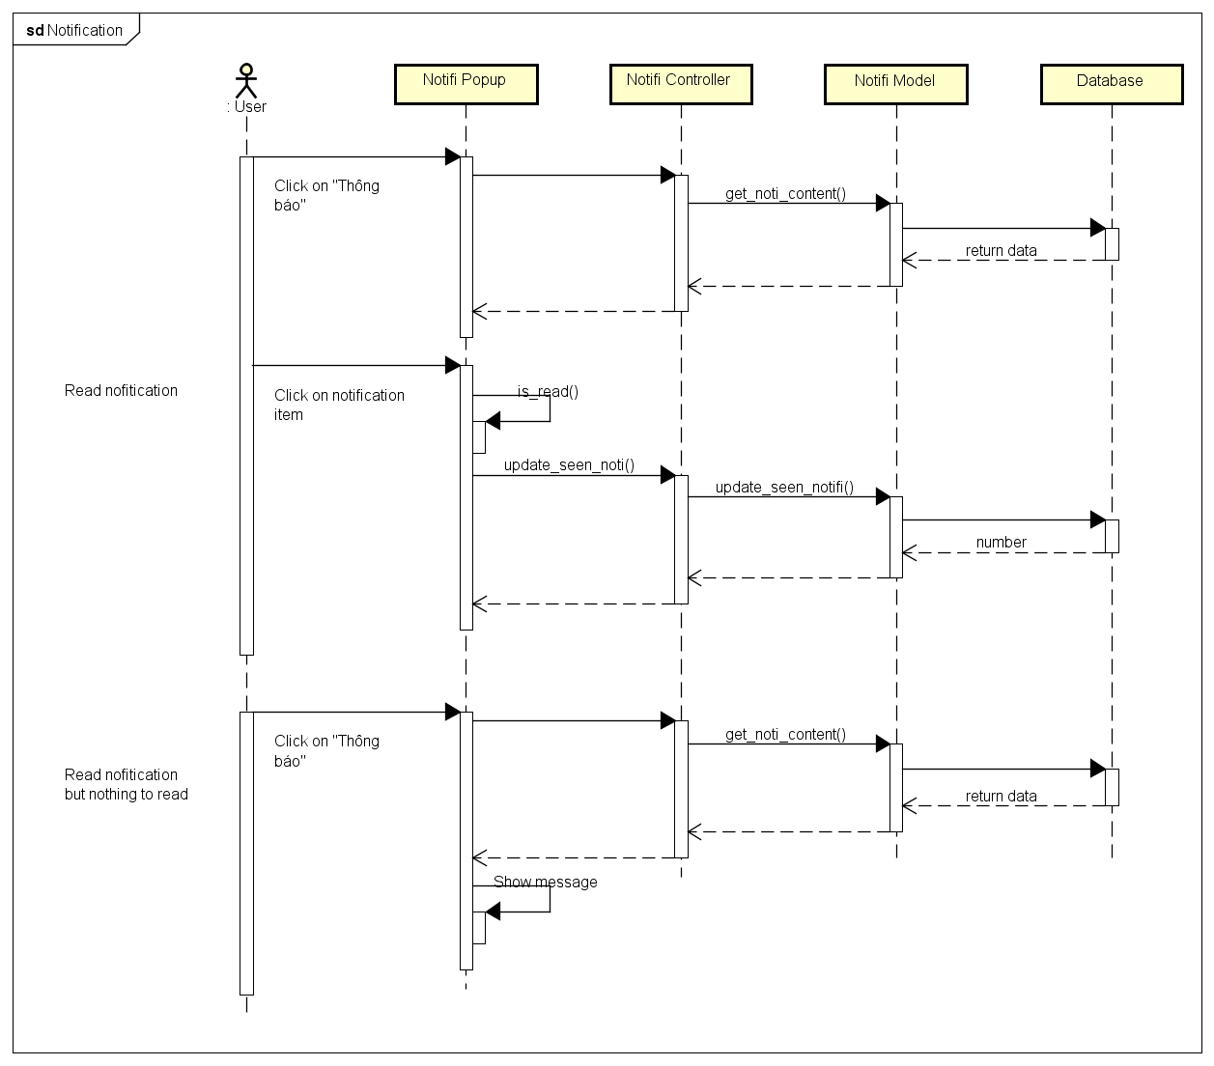

4.4.A.11. User Rankings

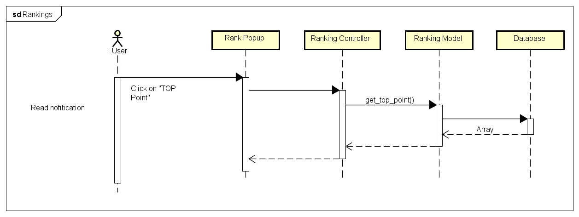

4.4.A.12. Create Challenges

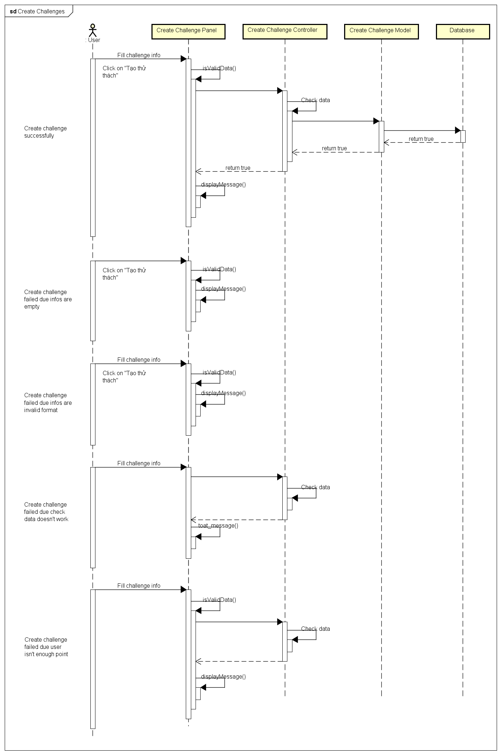

4.4.A.13. Bet On Traditional Game

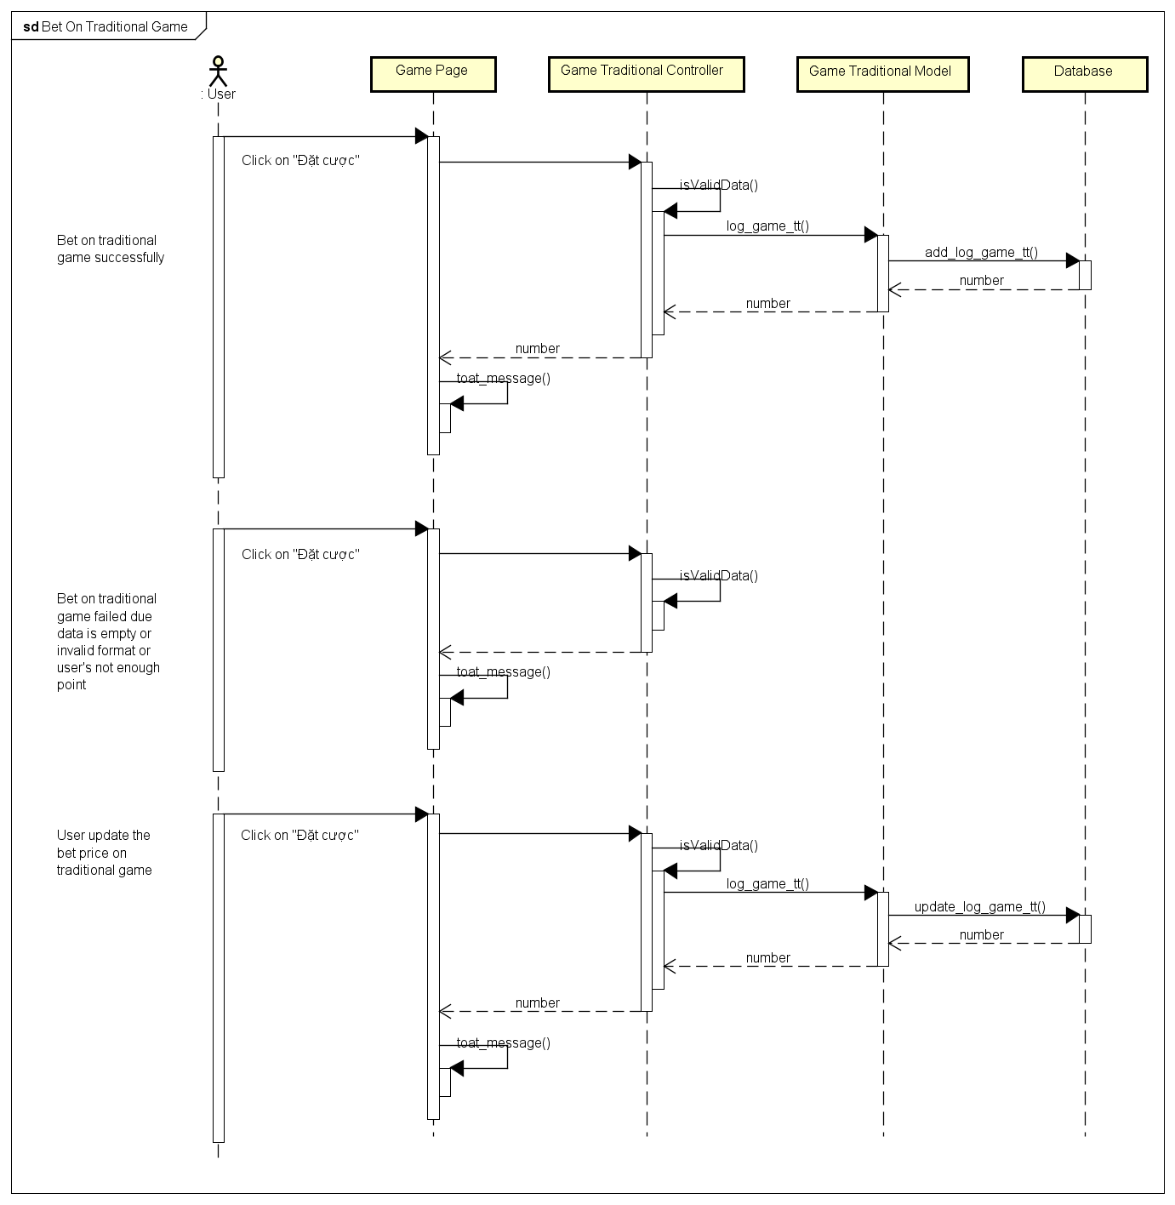

4.4.A.14. Bet On Challenge Game

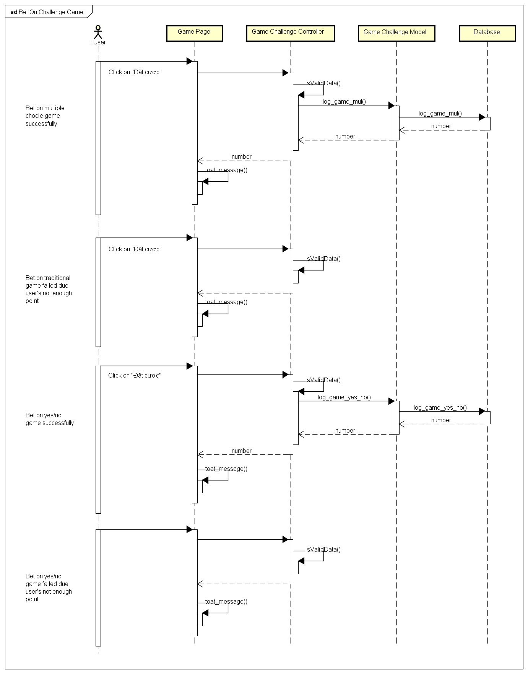

4.4.B. Admin Sequence Diagram

4.4.B.1. Login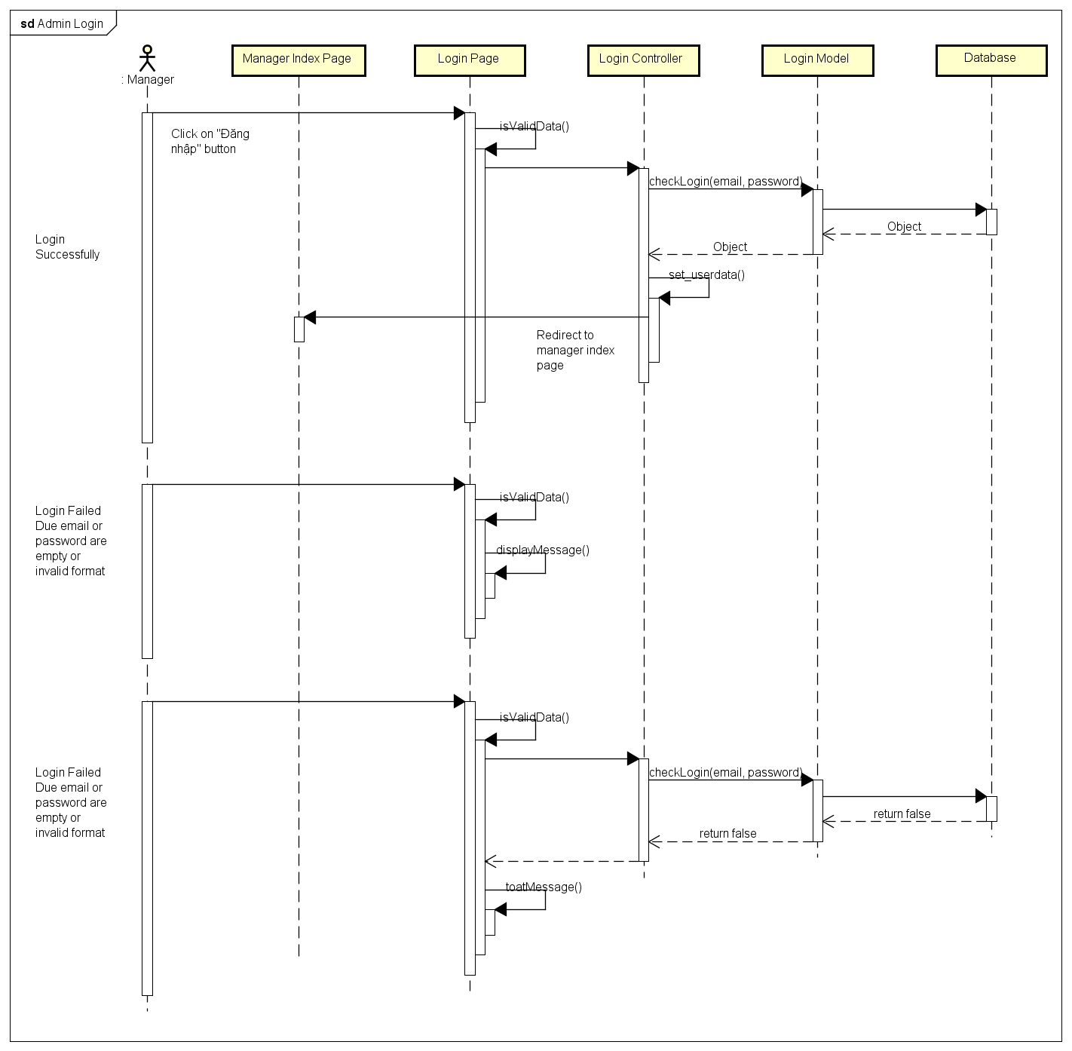

4.4.B.2. Notification

4.4.B.3. Send Notification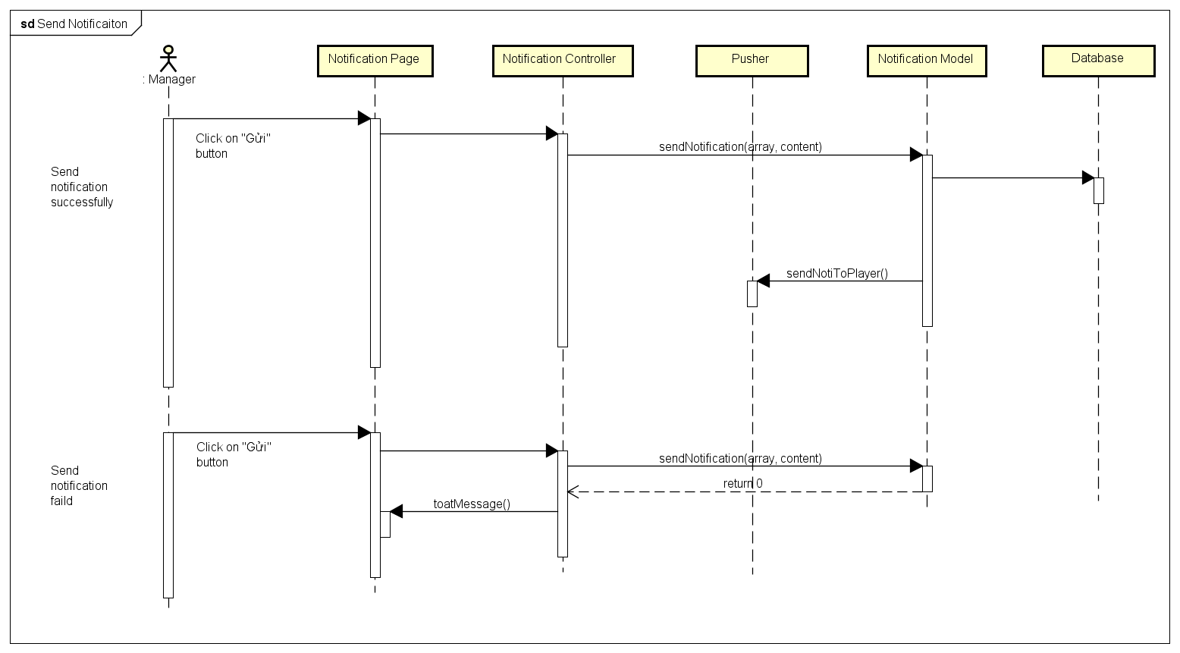

4.4.B.4. Delete Notification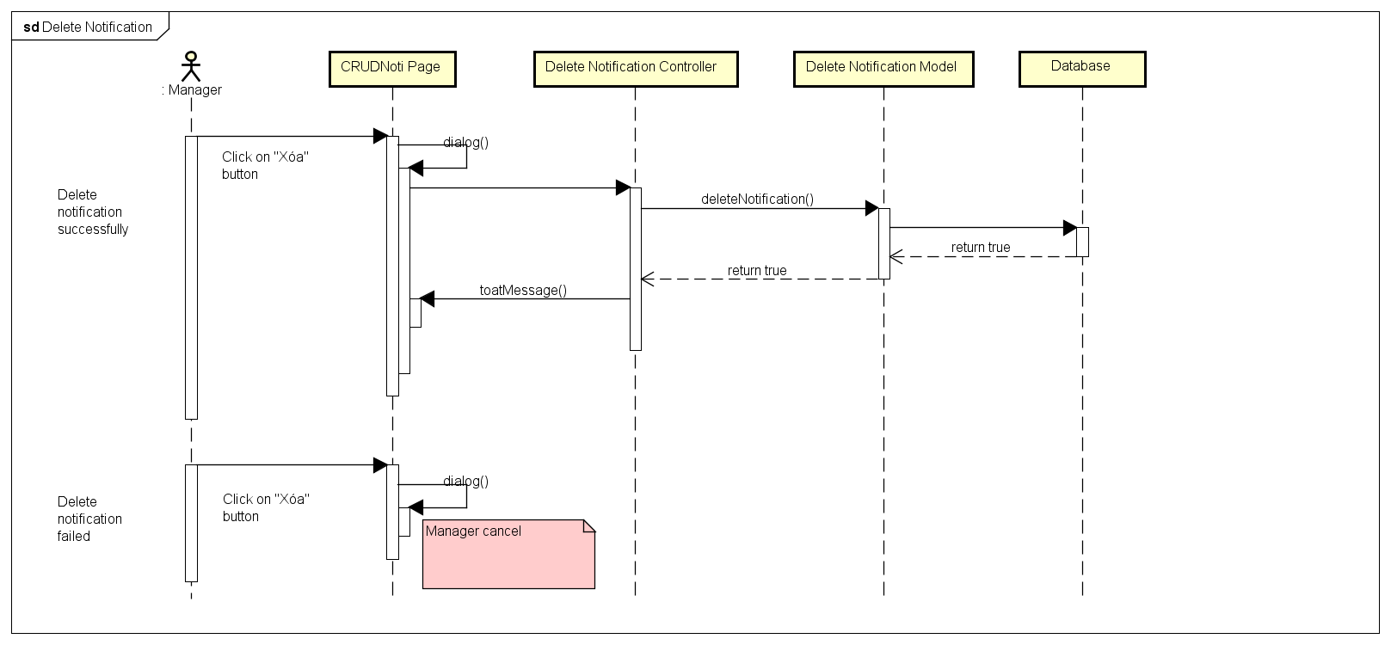

4.4.B.5. Edit Notification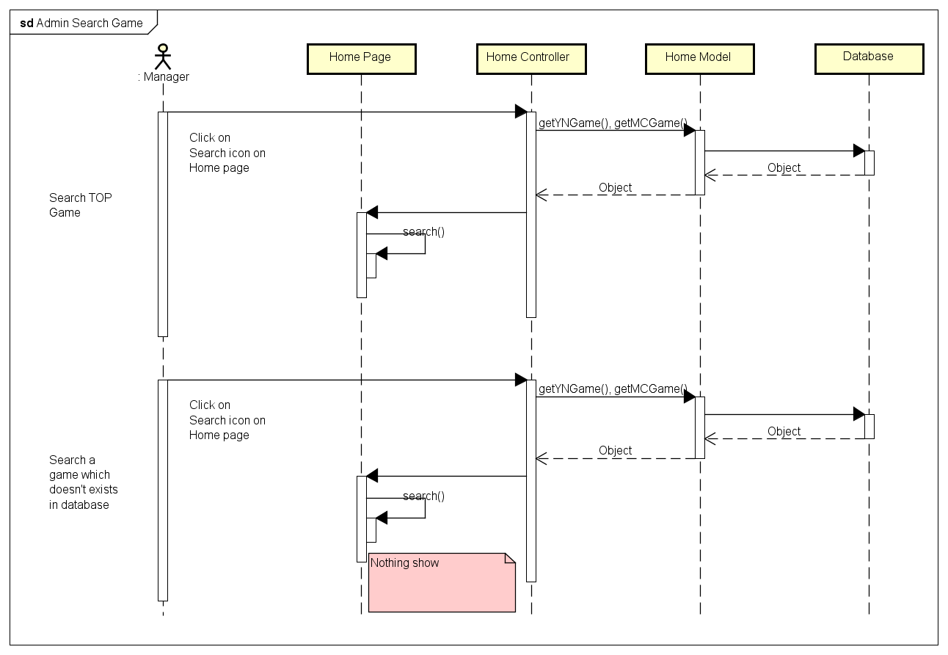

4.4.B.6. Search Game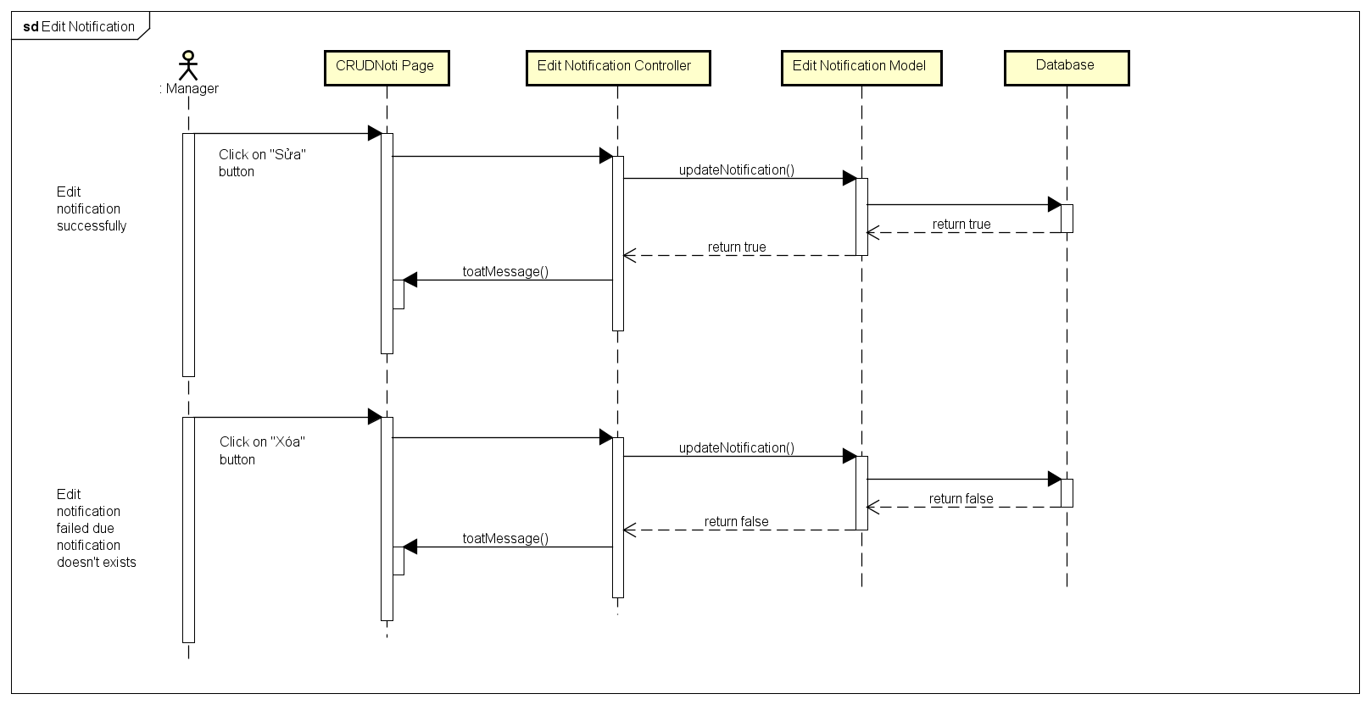

4.4.B.7. Search Member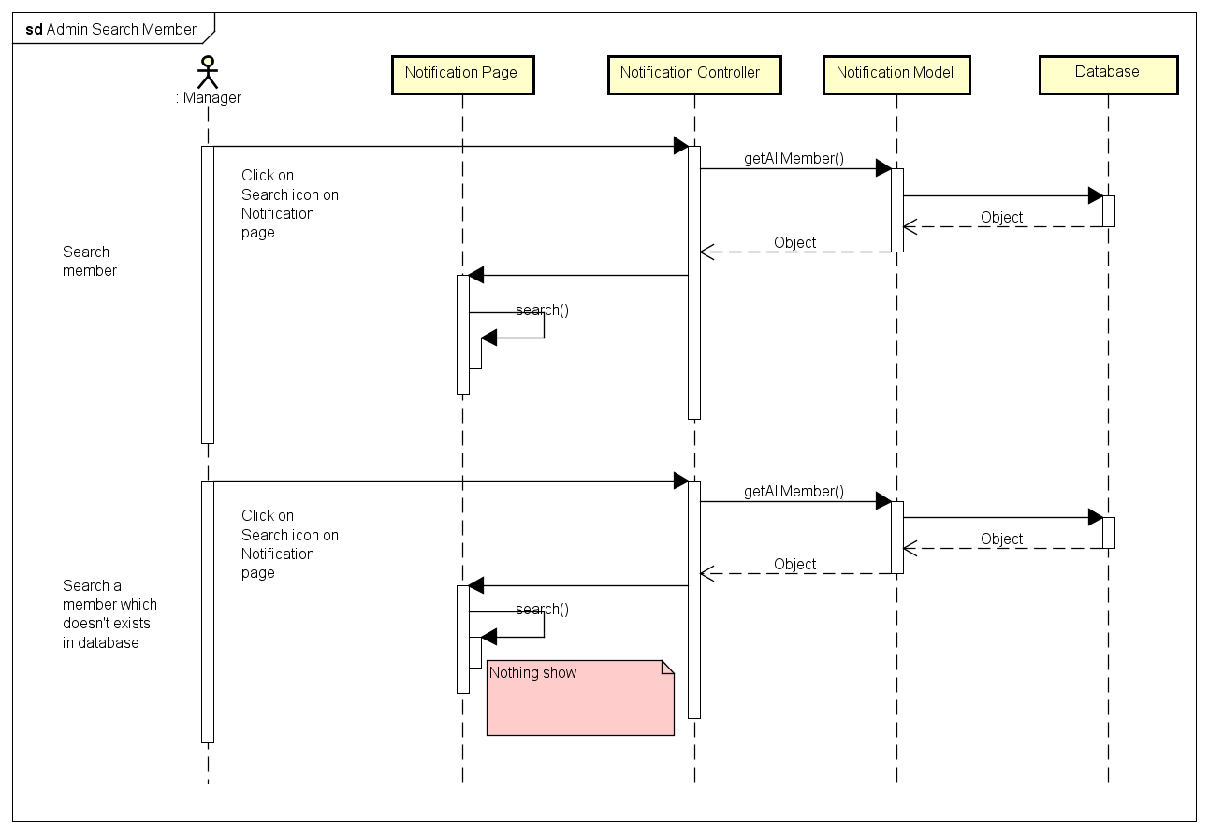

4.4.B.8. Block Manager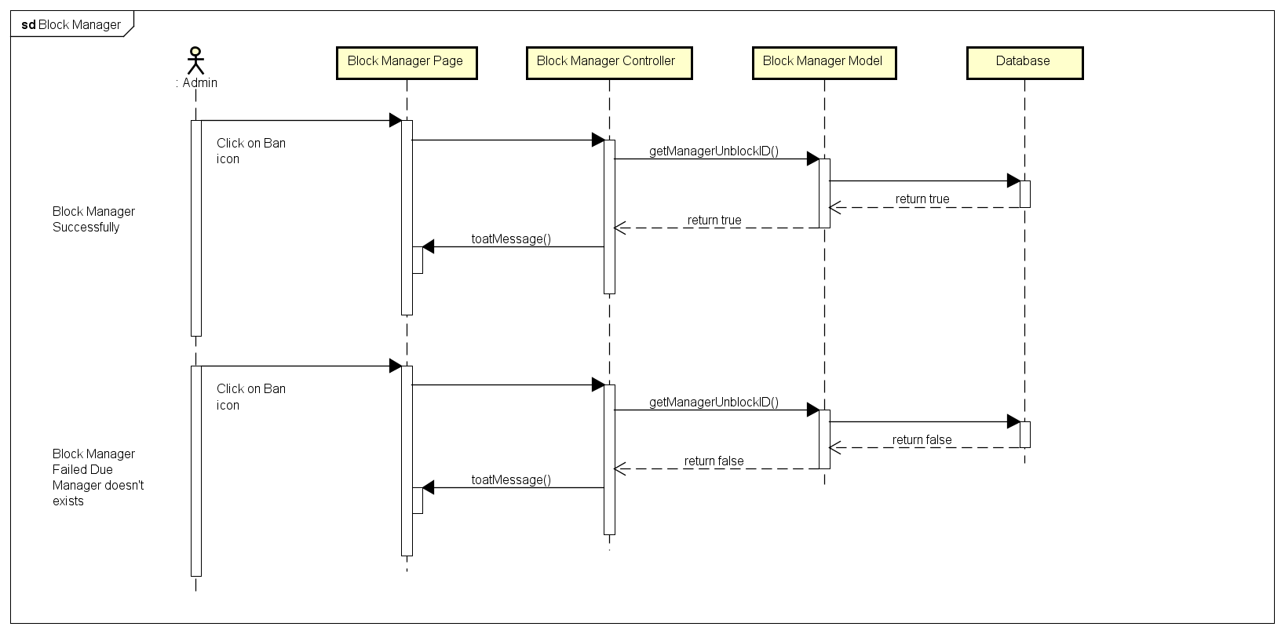

4.4.B.9. Unblock Manager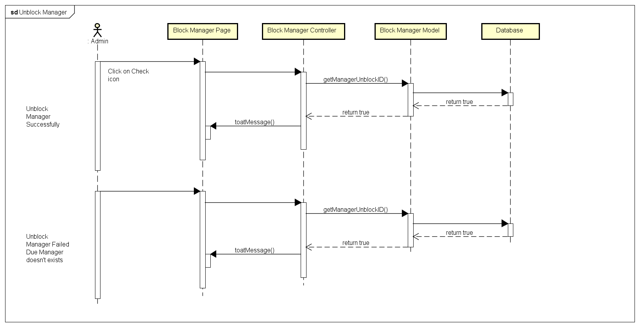

4.4.B.10. Change Gift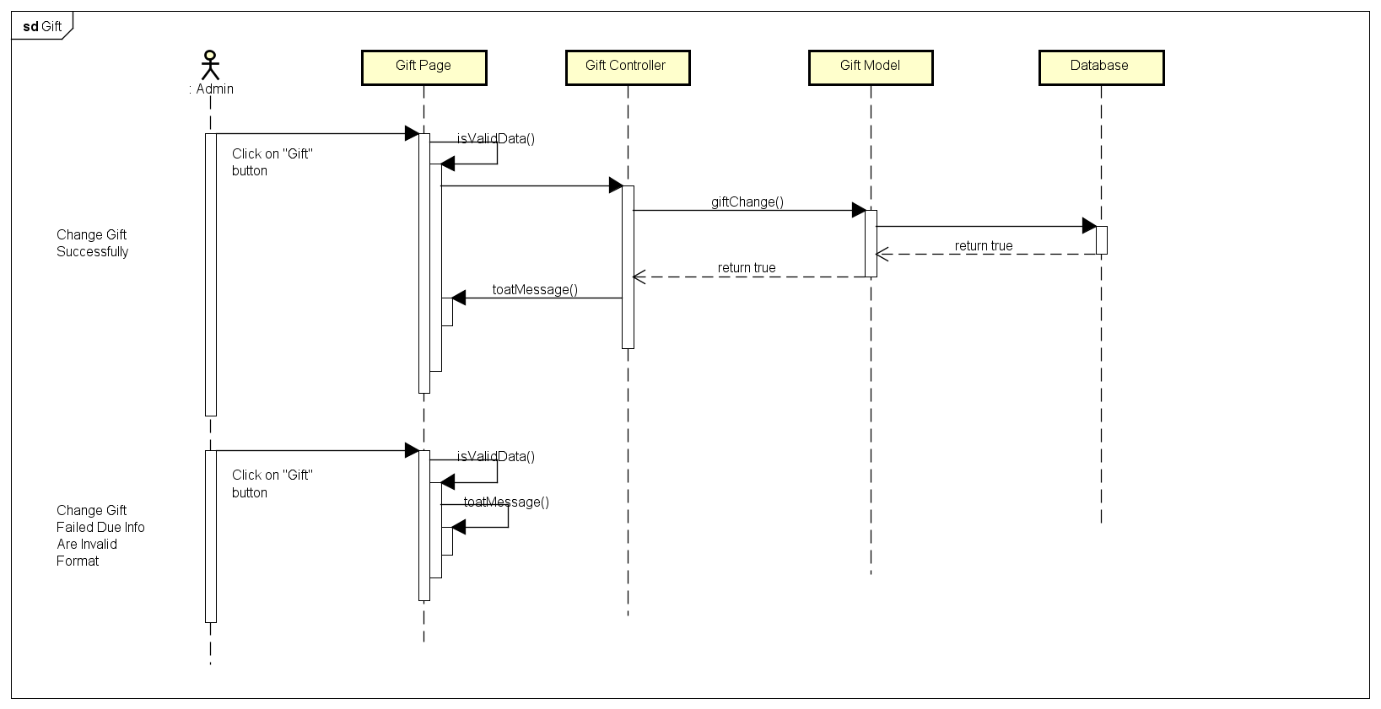

4.4.B.11. History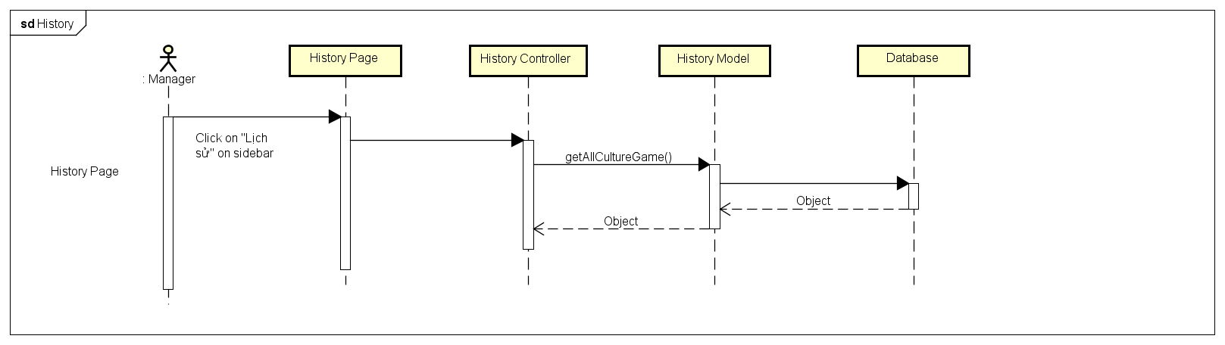

4.4.B.12. Create Game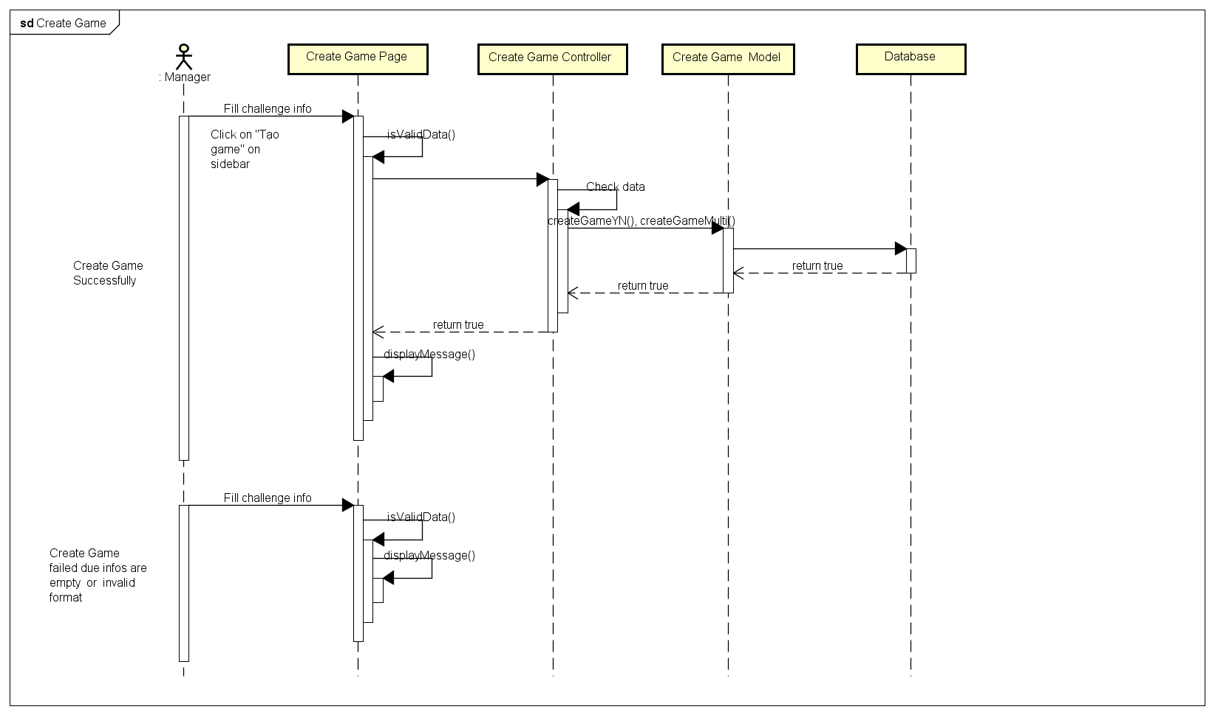

4.4.B.13. Edit Manager Information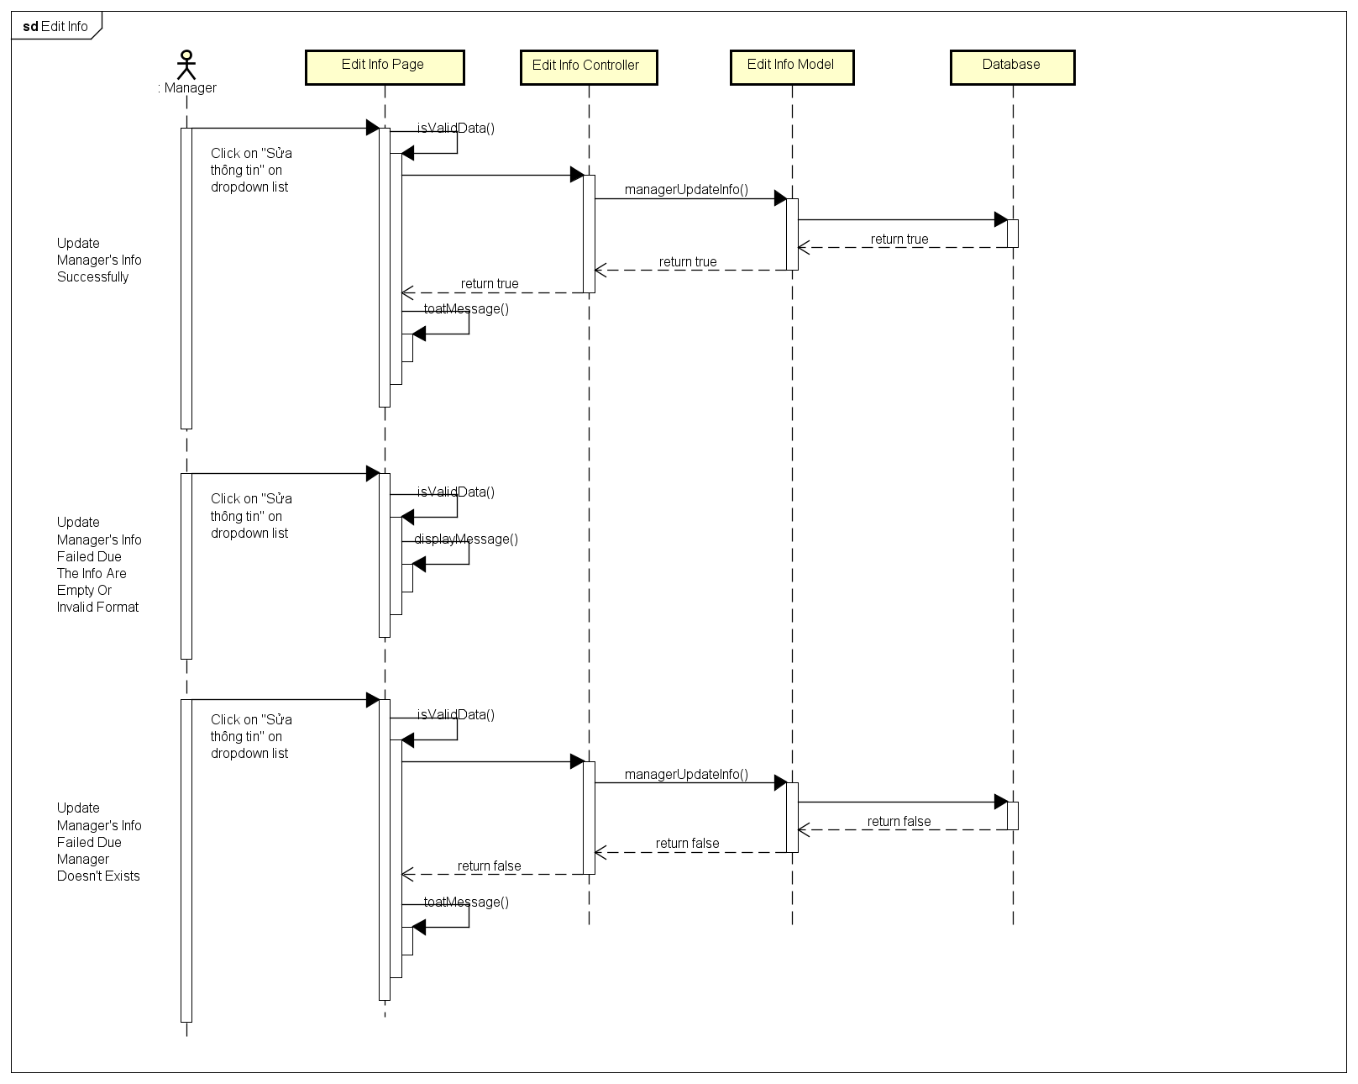

4.4.B.14. View Manager Information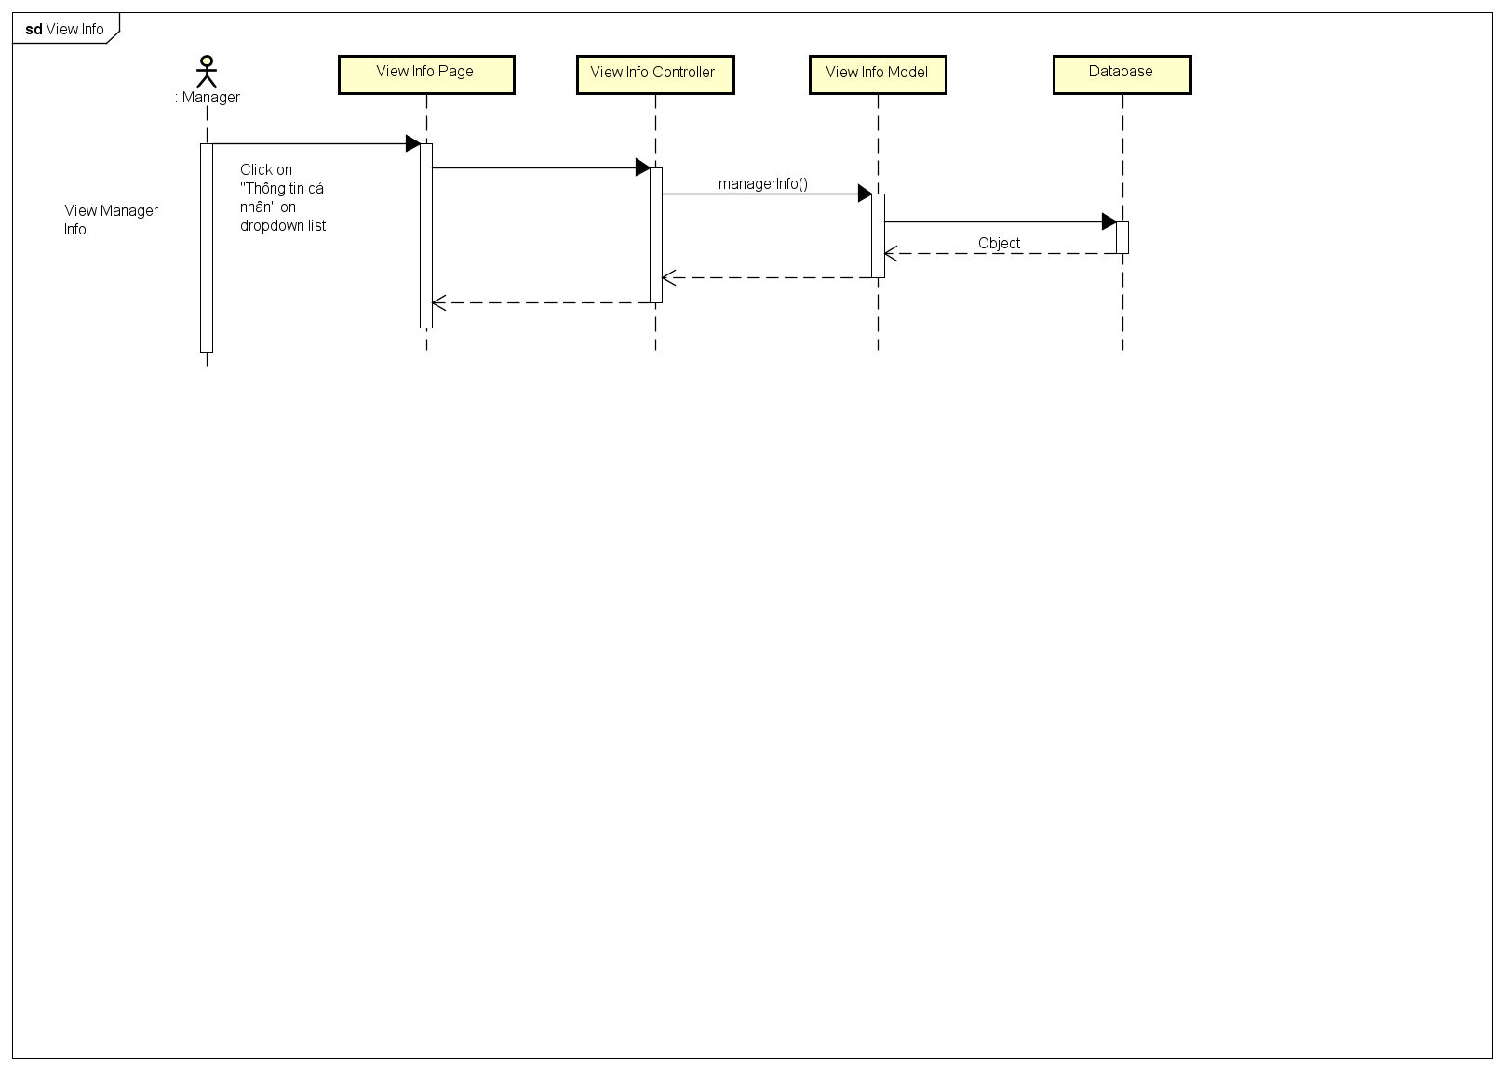

4.4.B.15. Change Password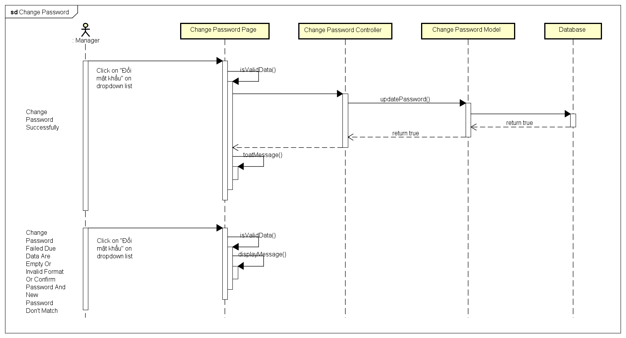

4.4.B.16. Forgot Password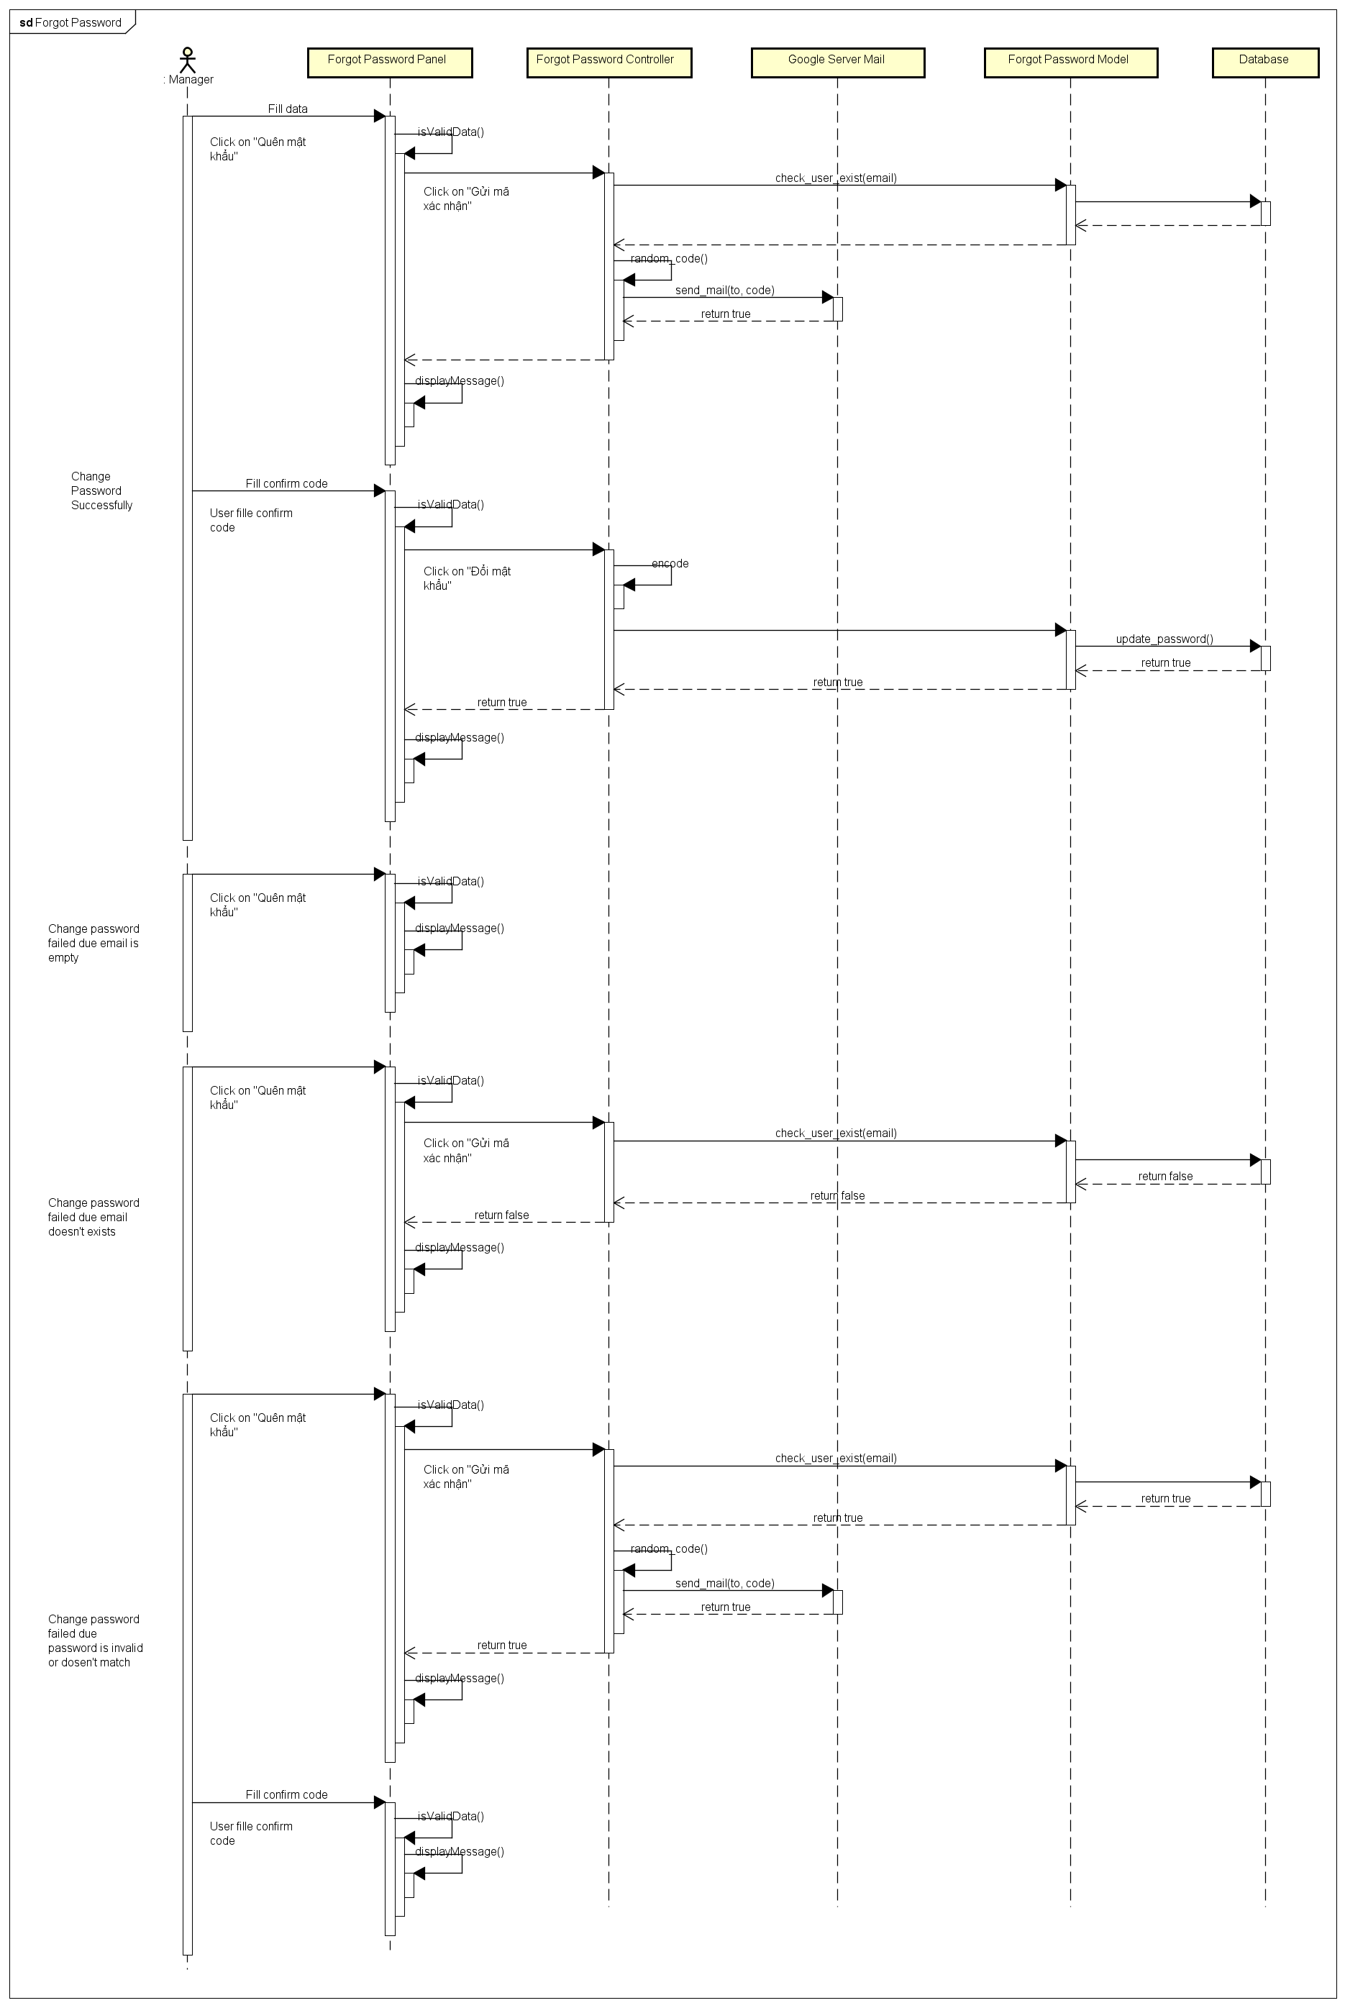

4.5.A. Activities Diagram

4.5.A.1. Register and Login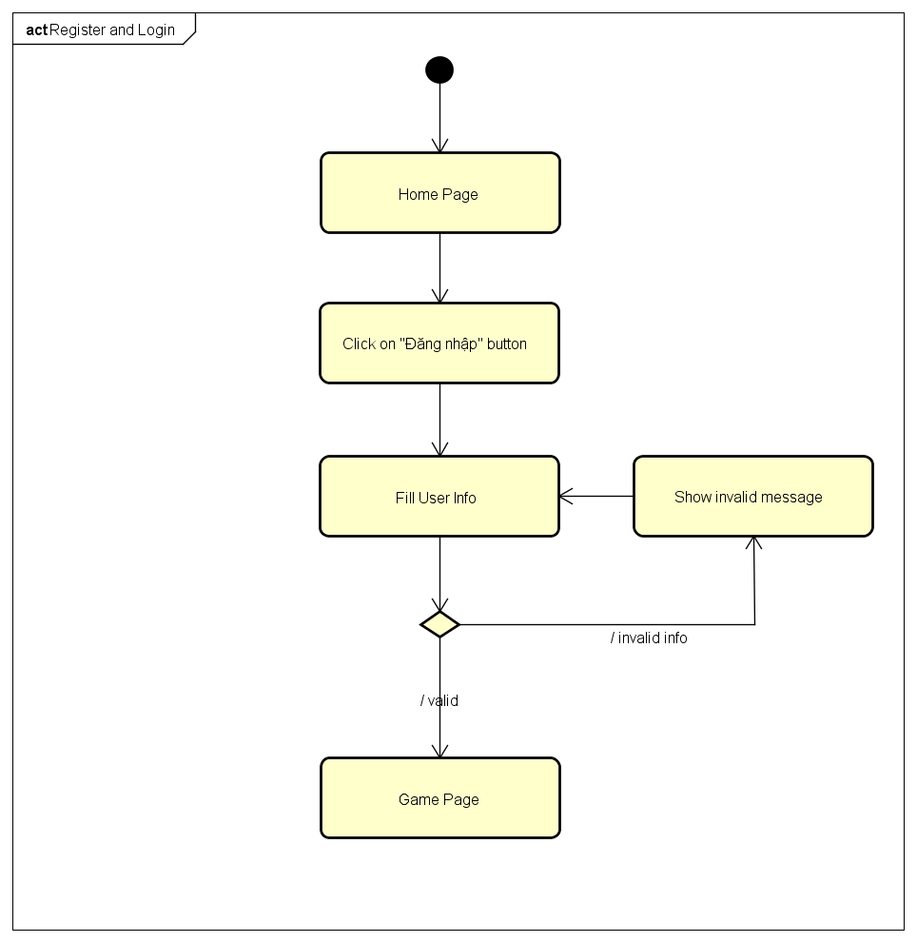

4.5.A.2. Login Using Facebook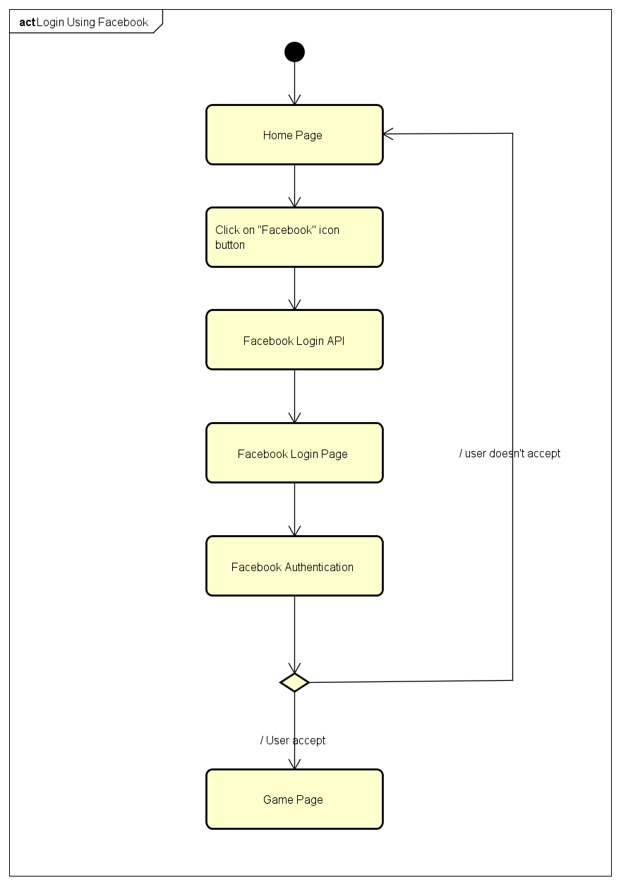

4.5.A.3. Login Using Google Plus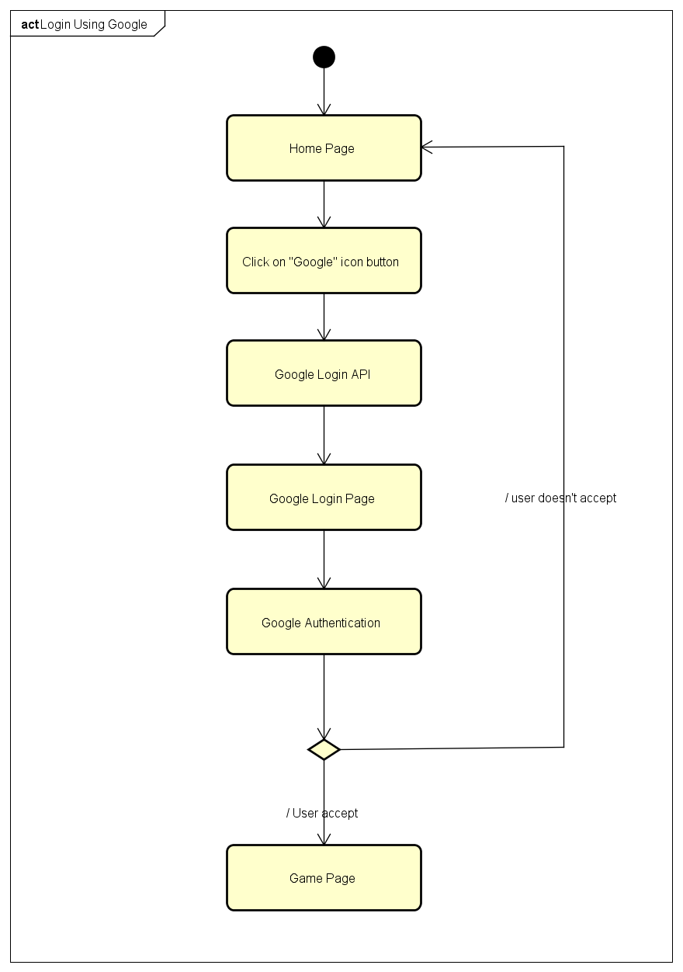

4.5.A.4. Logout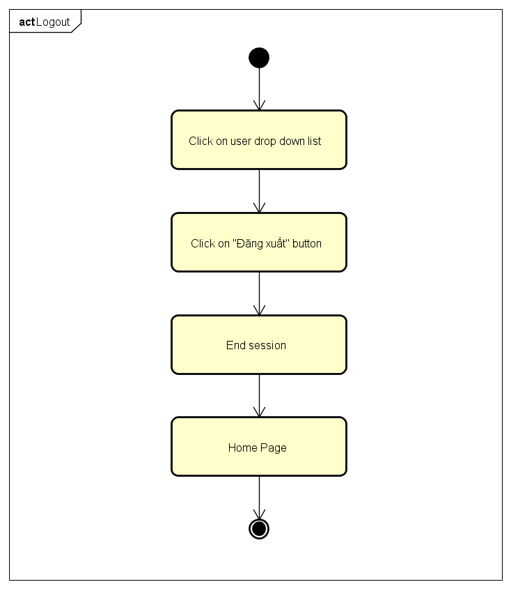

4.5.A.5. Change Password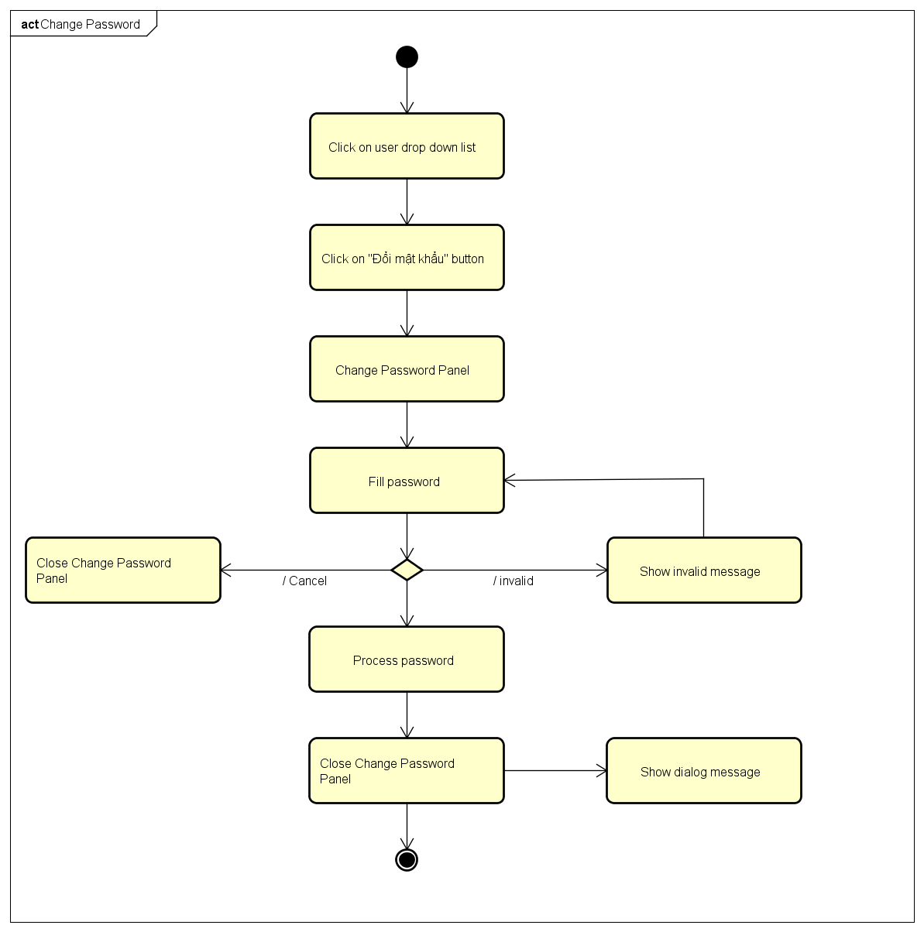

4.5.A.6. Forgot Password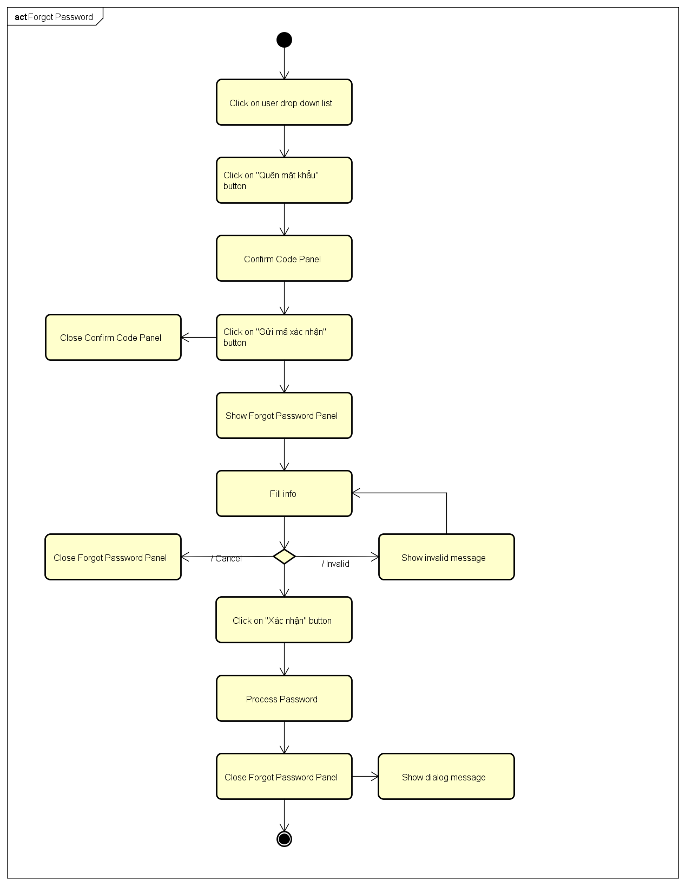

4.5.A.7. Edit Profile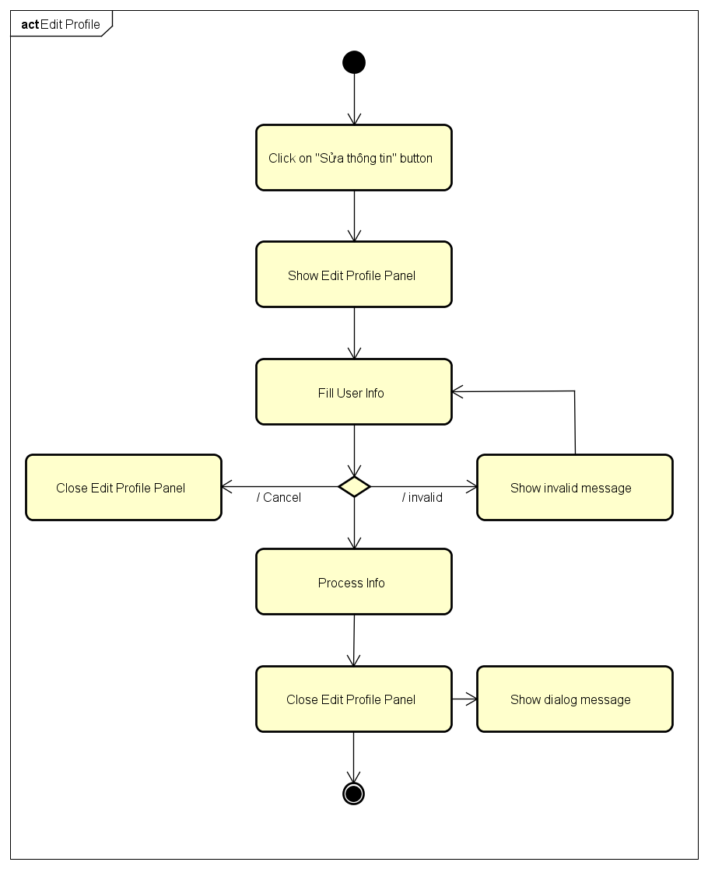

4.5.A.8. History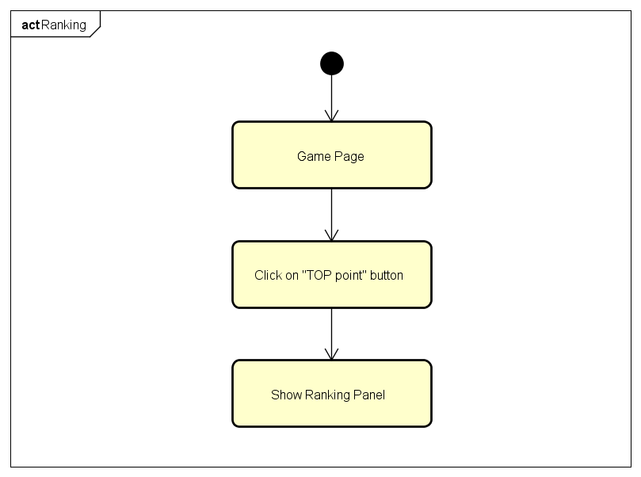

4.5.A.9. Notification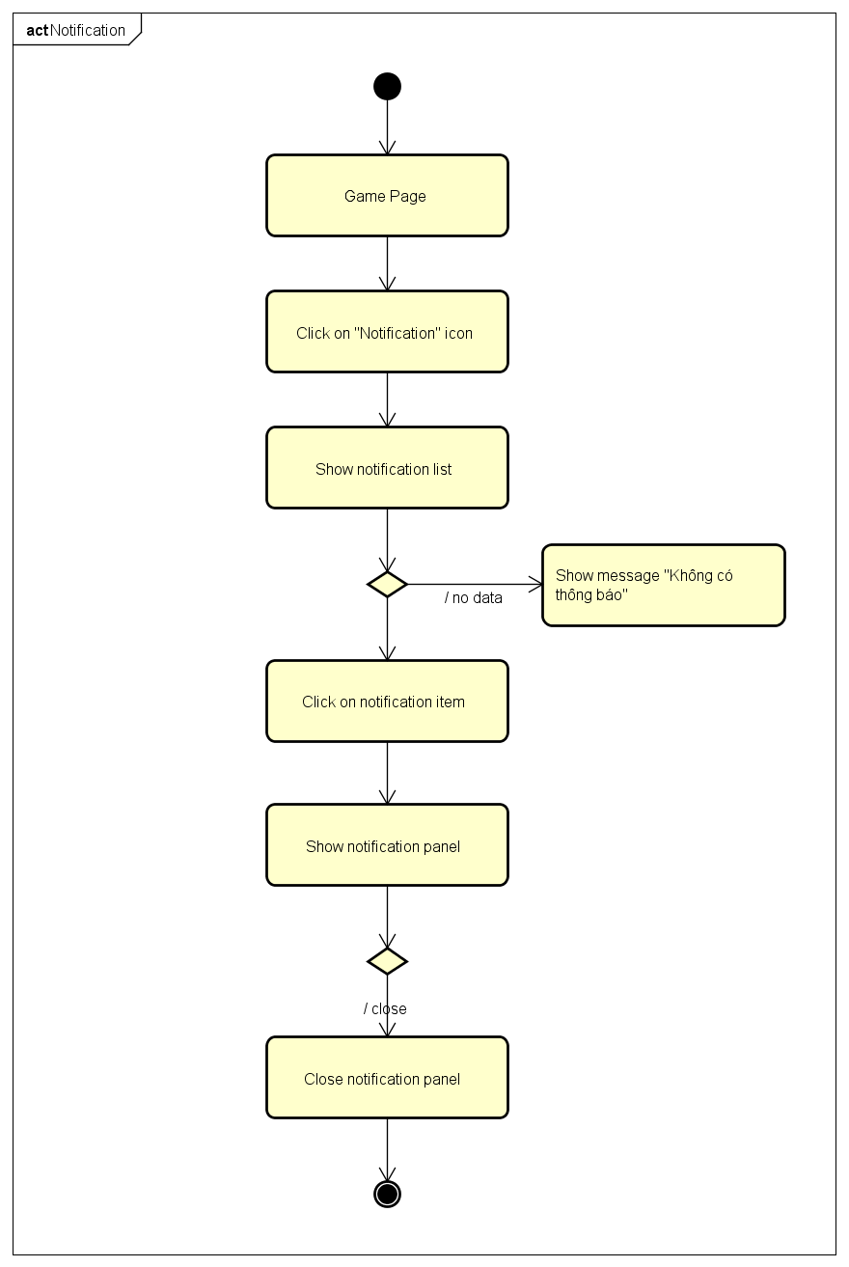

4.5.A.10. Ranking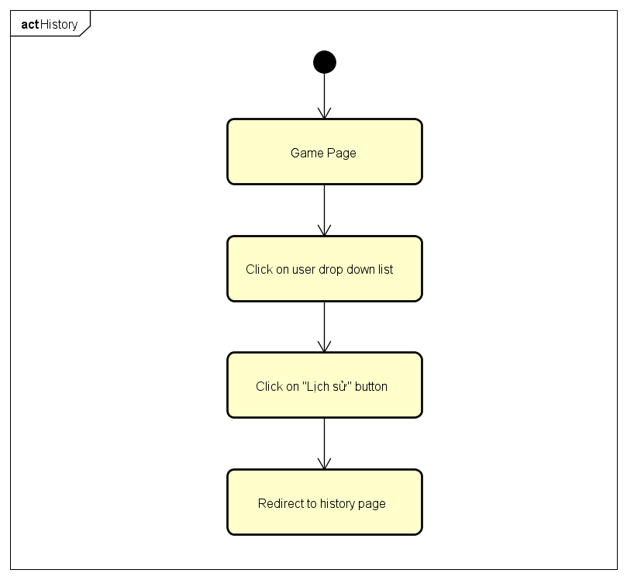

4.5.A.11. Create Challenges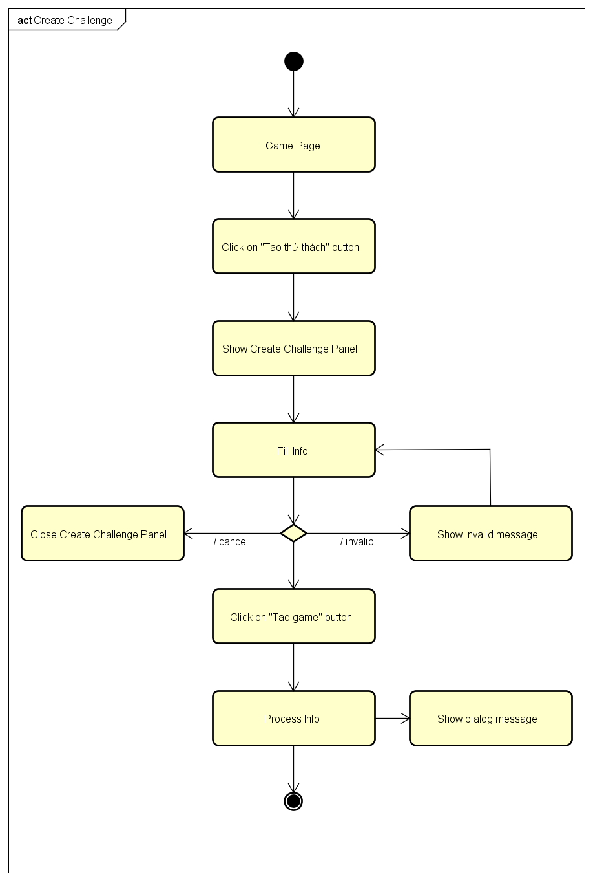

4.5.A.12. Bet On Traditional Game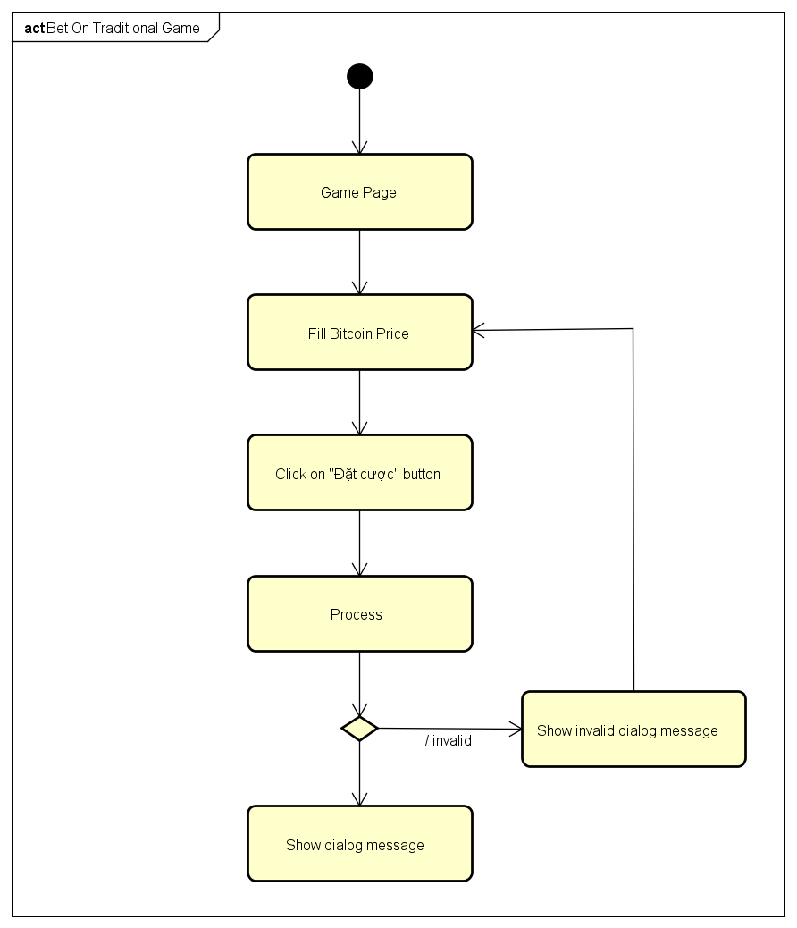

4.5.A.13. Bet On Challenge Game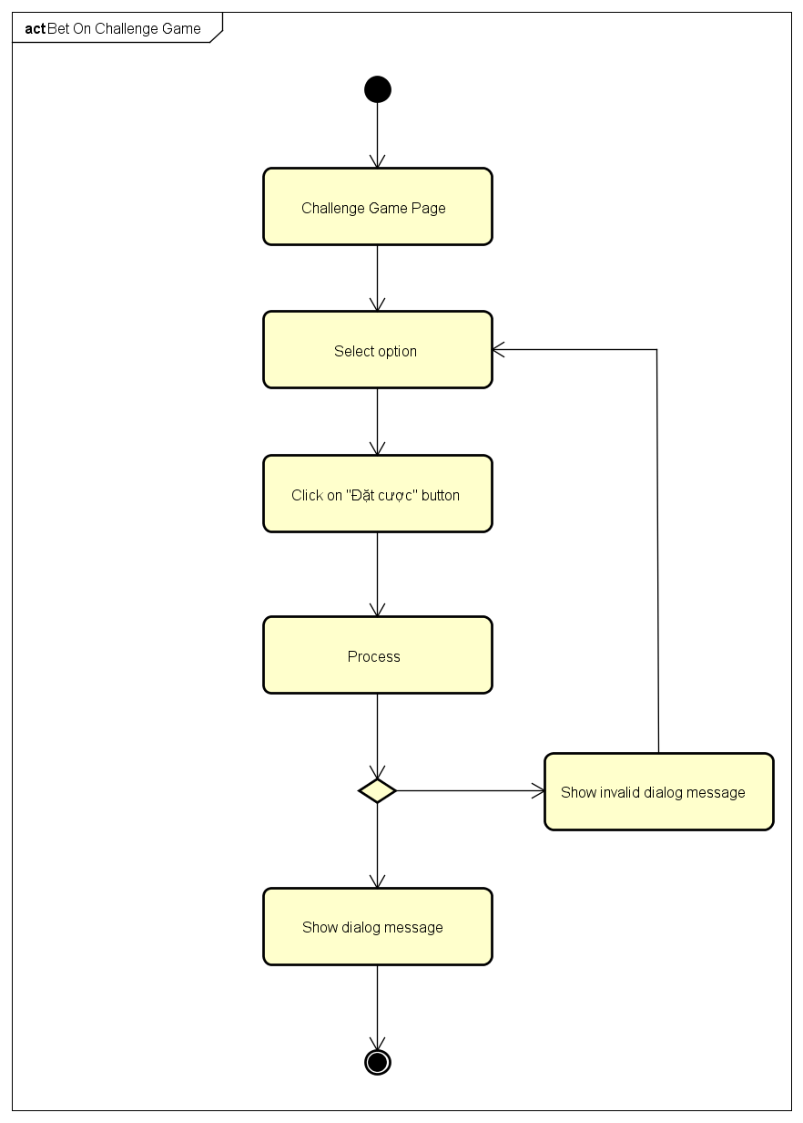

4.5.B. Admin Activities Diagram

4.5.B.1. Login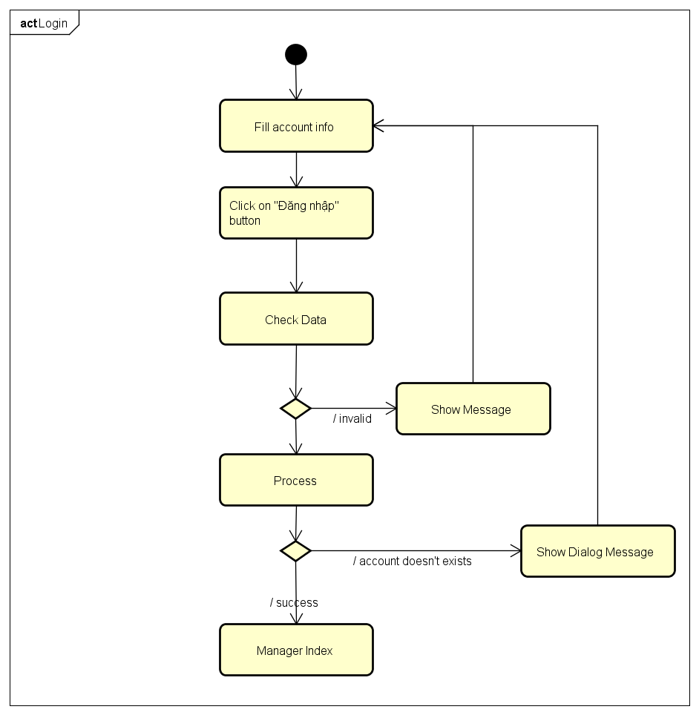

4.5.B.2. Send Notification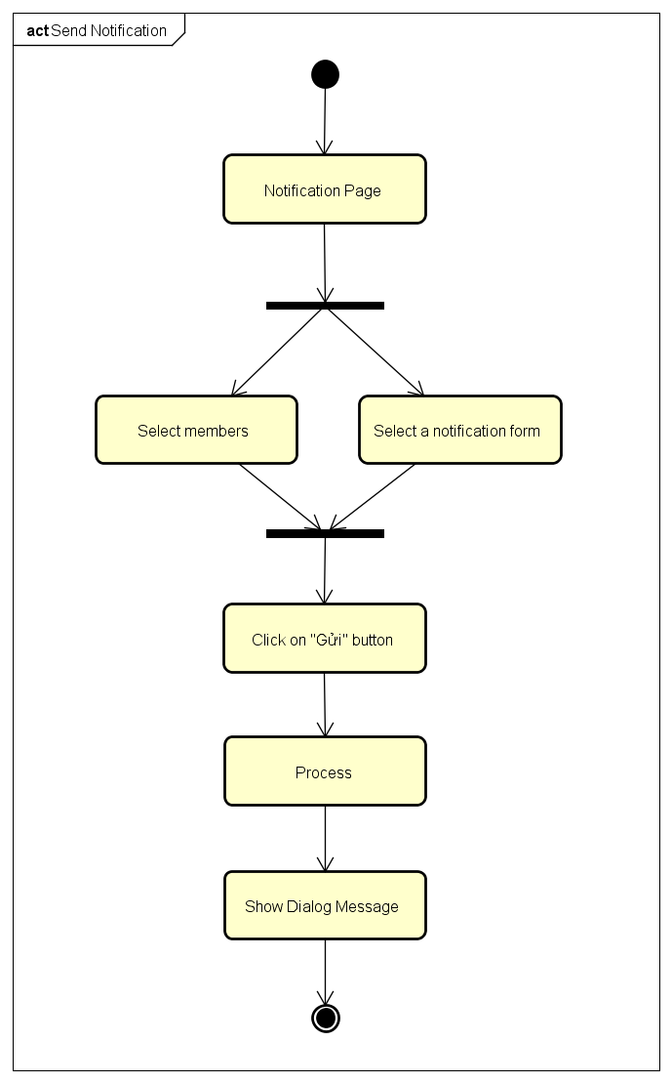

4.5.B.3.Add Notification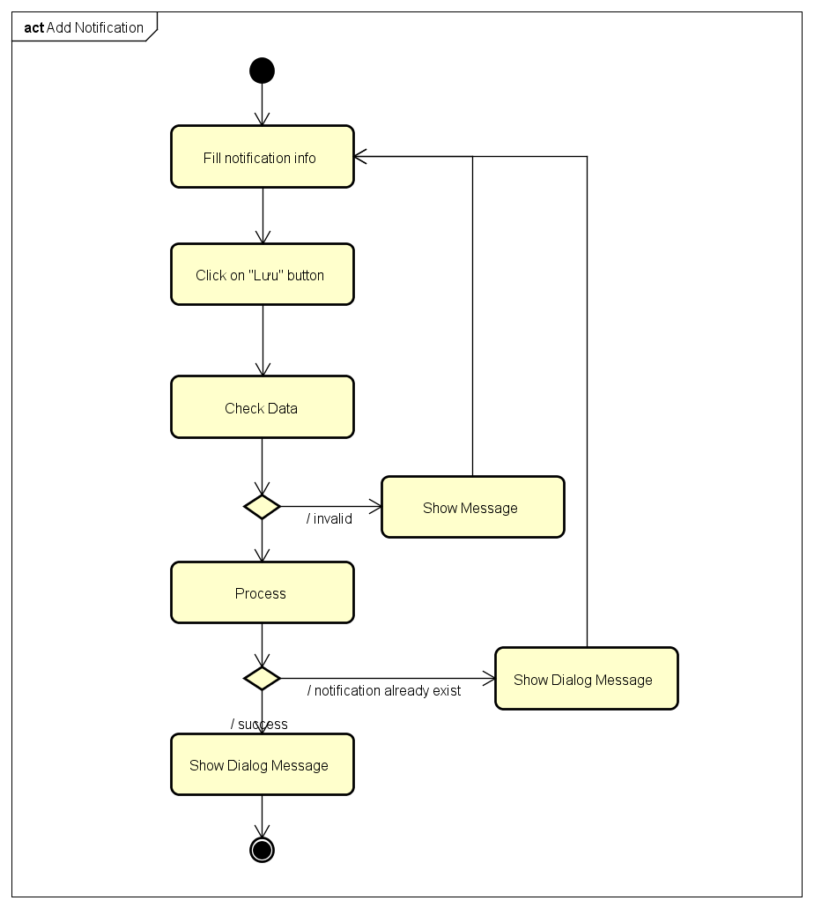

4.5.B.4.Delete Notification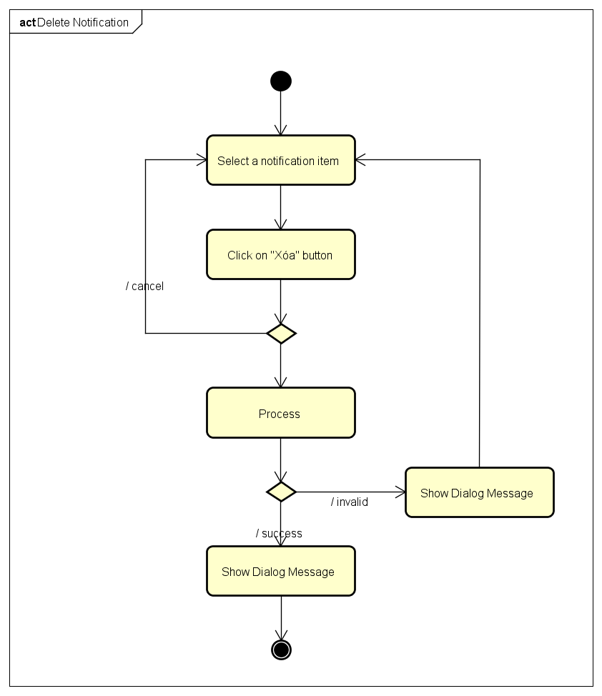

4.5.B.5.Edit Notification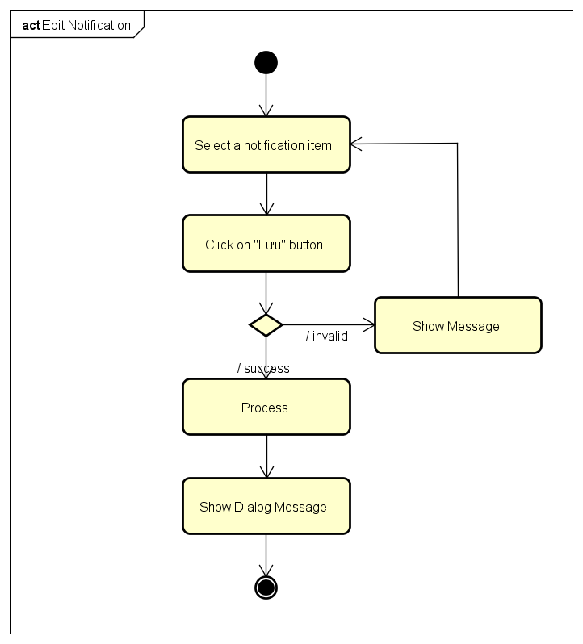

4.5.B.6.Search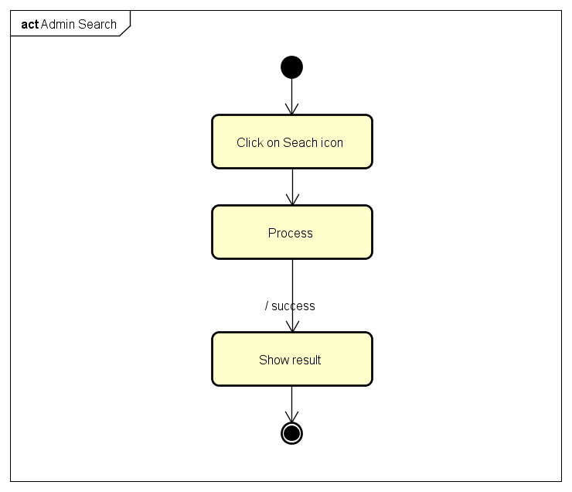

4.5.B.7.Block Manager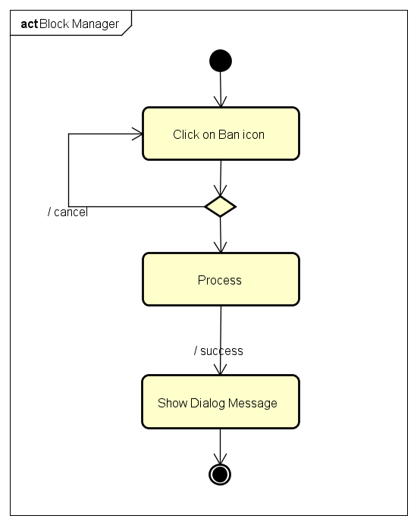

4.5.B.8.Unblock Manager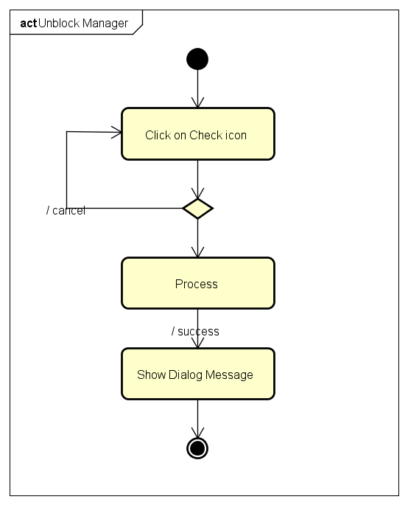

4.5.B.9.Change Gift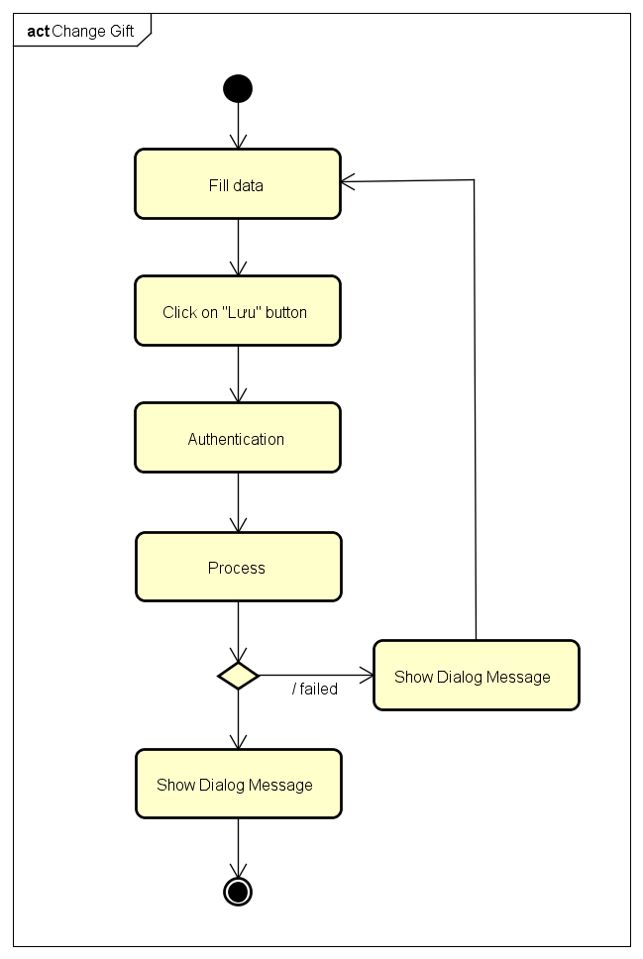

4.5.B.10.History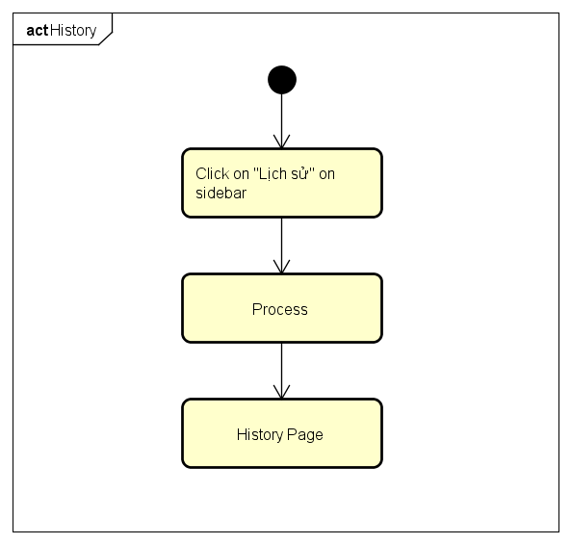

4.5.B.11.Create Game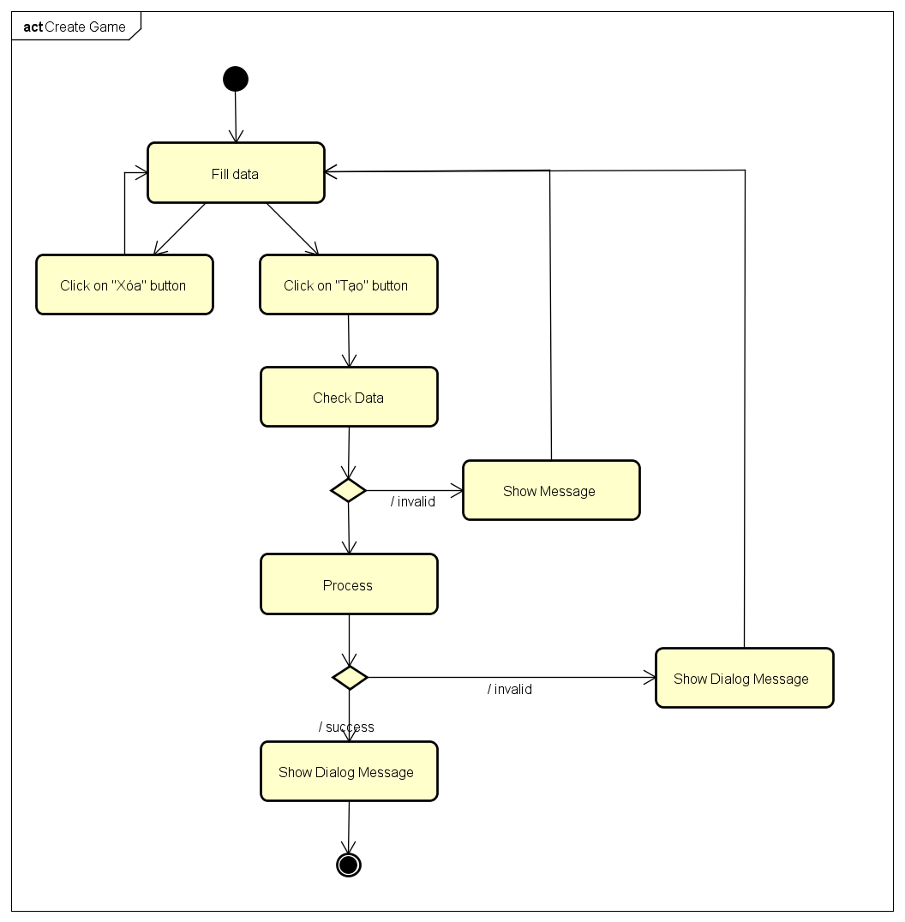

4.5.B.12.Edit Manager Information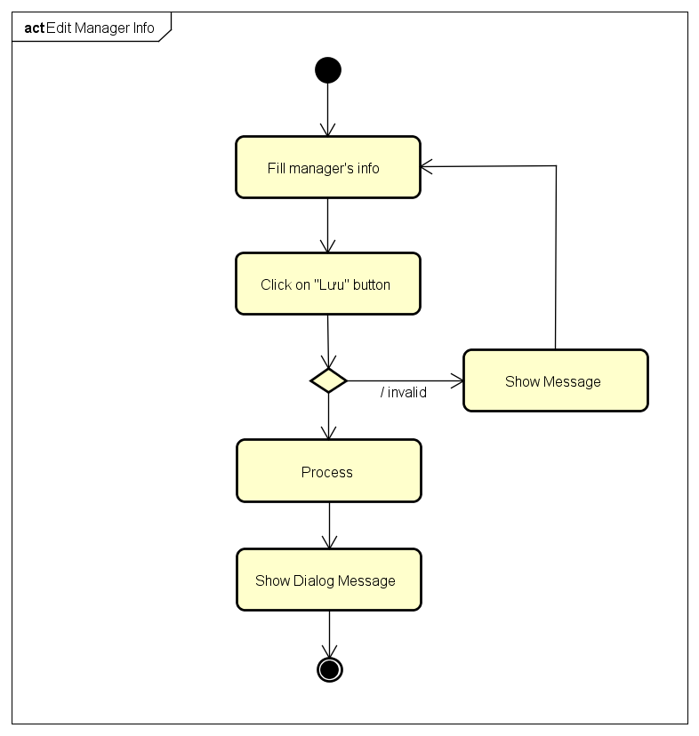

4.5.B.13.View Manager Information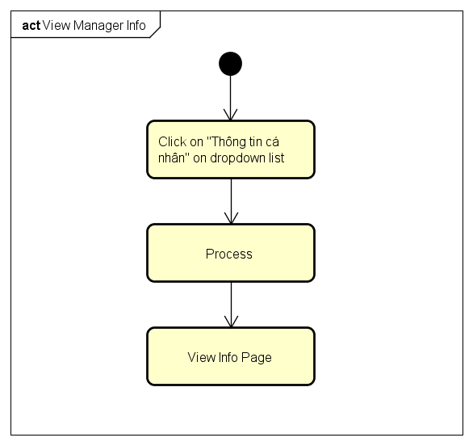

4.5.B.14.Change Password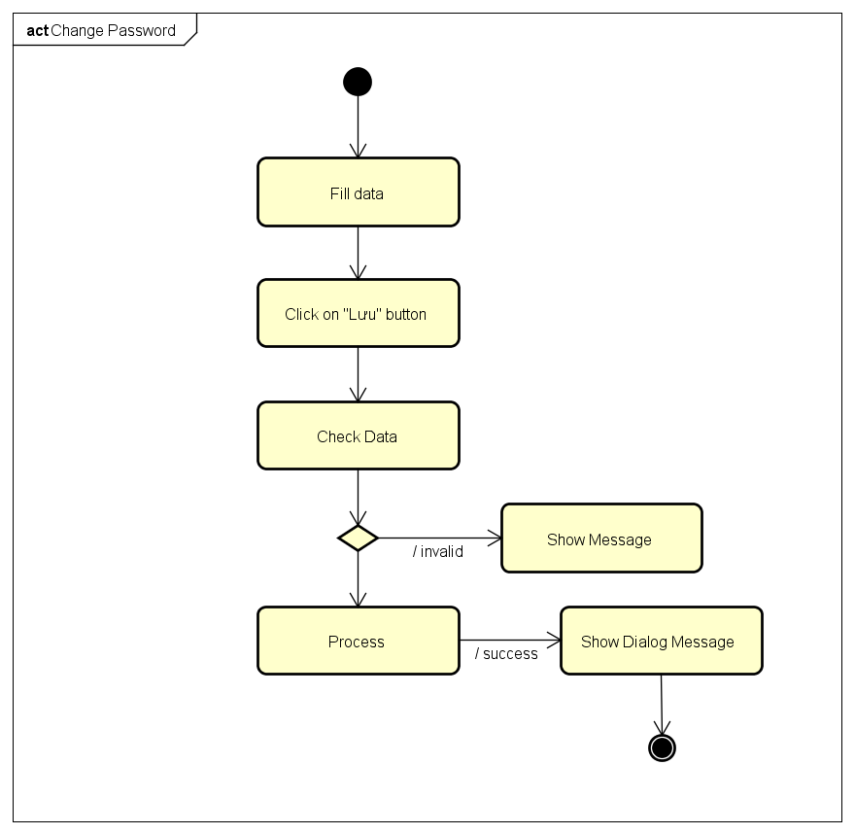

4.5.B.15.Forgot Password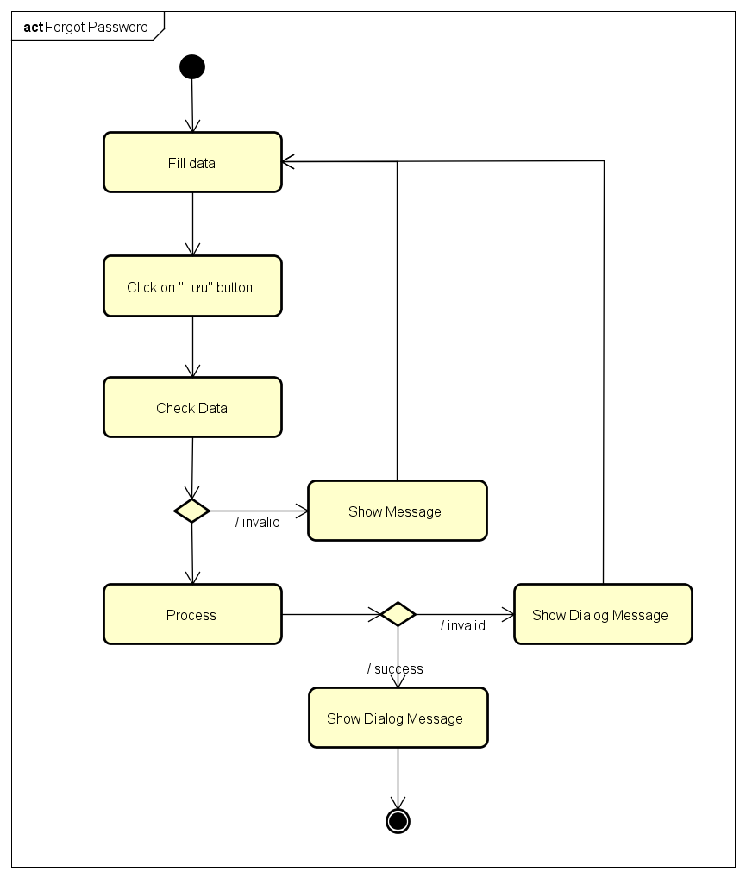

4.6. CRC Cards and Class Diagram

4.6.1. CRC Cards

4.6.2. Class Diagram

4.7. User Interface Design

4.7.1. Register and Login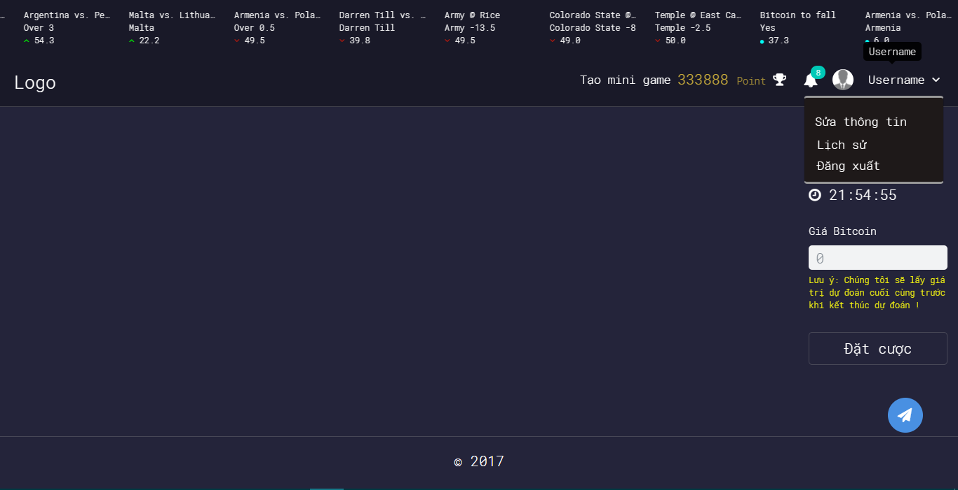

4.7.2. Login Using Facebook

4.7.3. Login Using Google Plus

4.7.4. Logout

4.7.5. Change Password

4.7.6. Forgot Password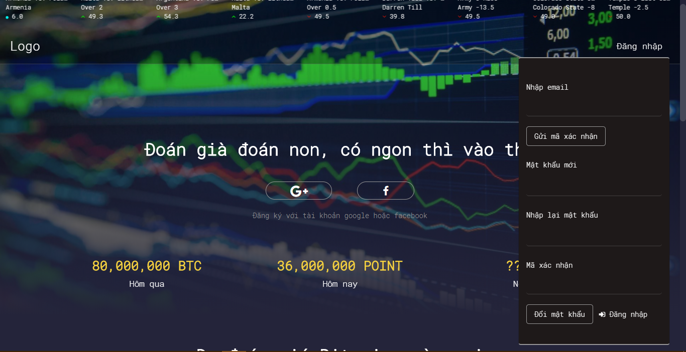

4.7.7. Edit Profile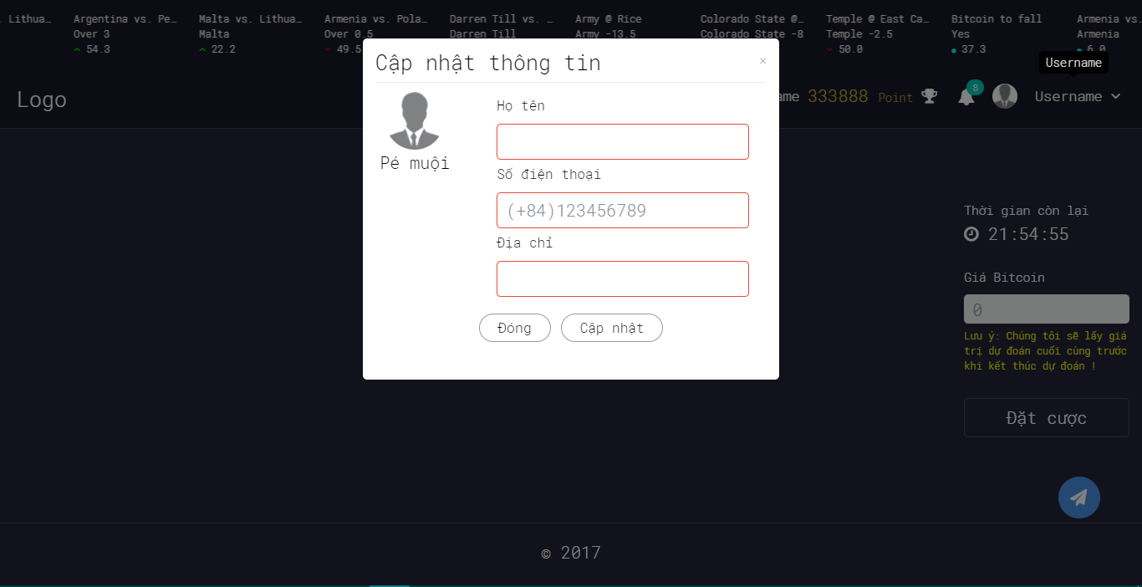

4.7.8. History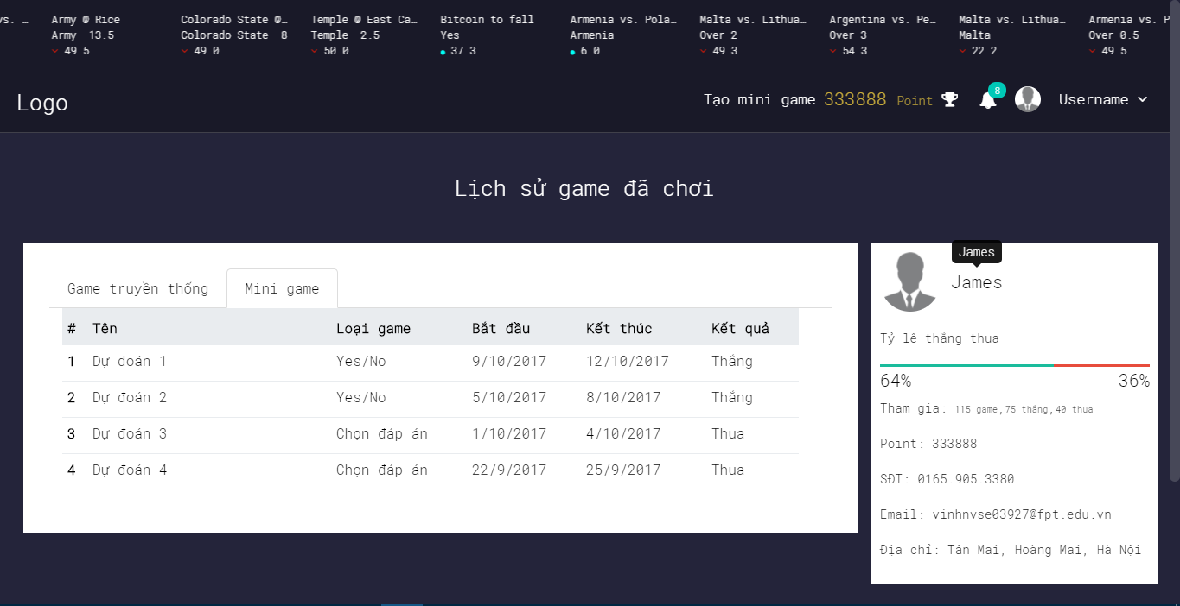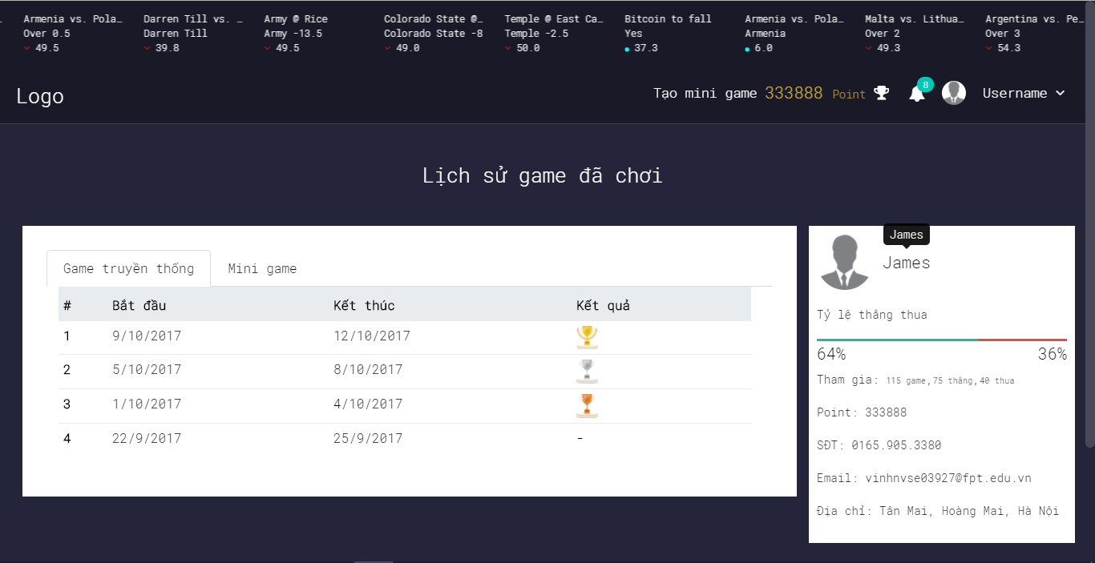

4.7.9. Notification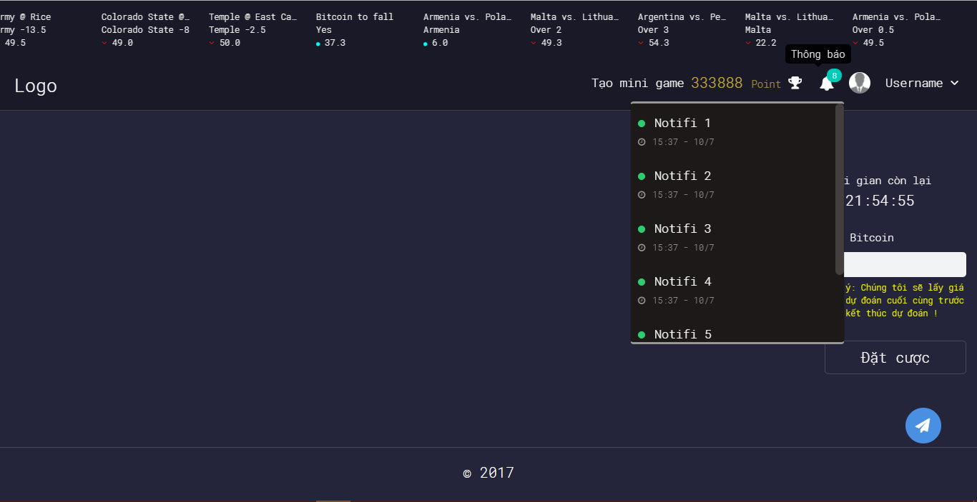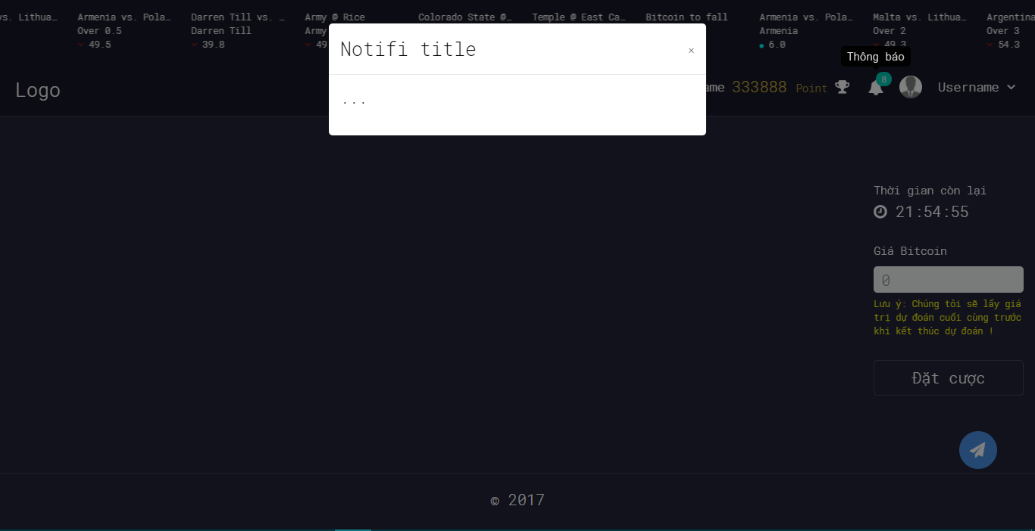

4.7.10. Ranking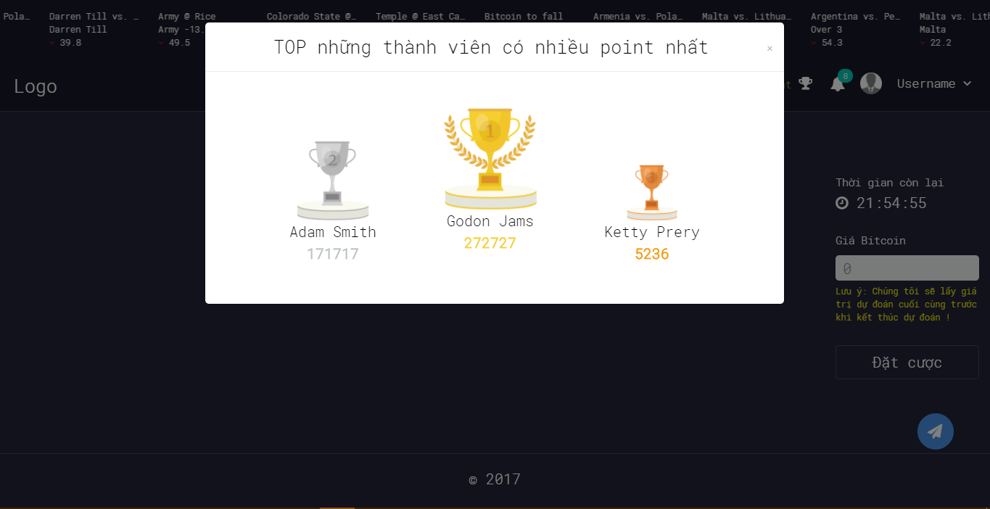

4.7.11. Create Yes/No Game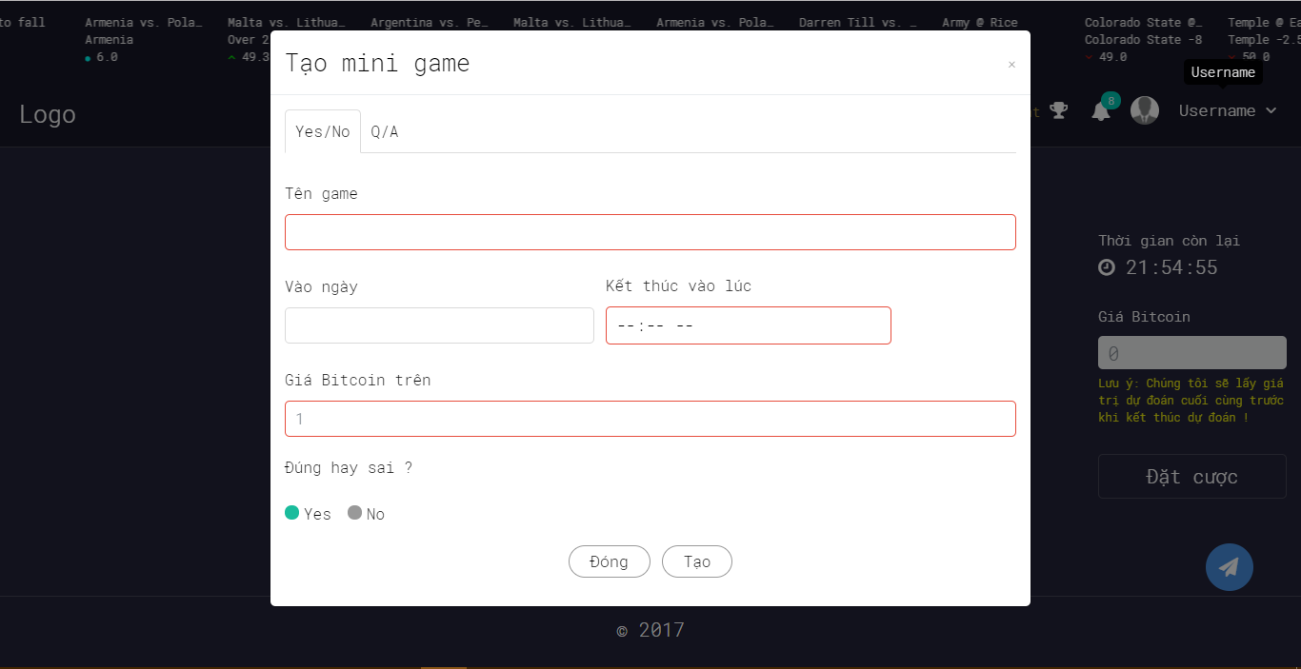

4.7.12. Create Multiple Choice Game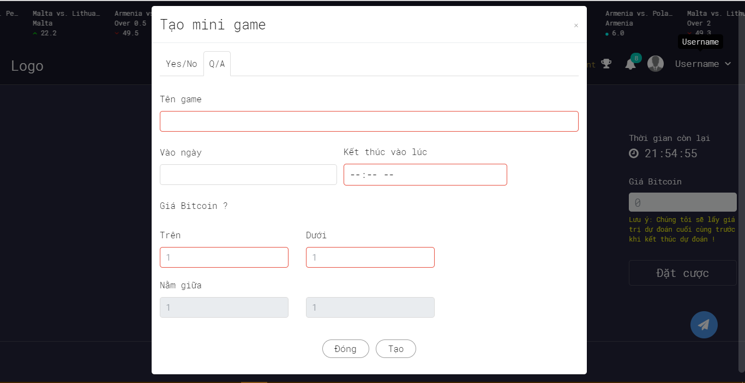

4.7.13. Bet On Traditional Game

4.7.14. Bet On Yes/No Game

4.7.15. Bet On Multiple Choice Game

4.7.16. YES/No Game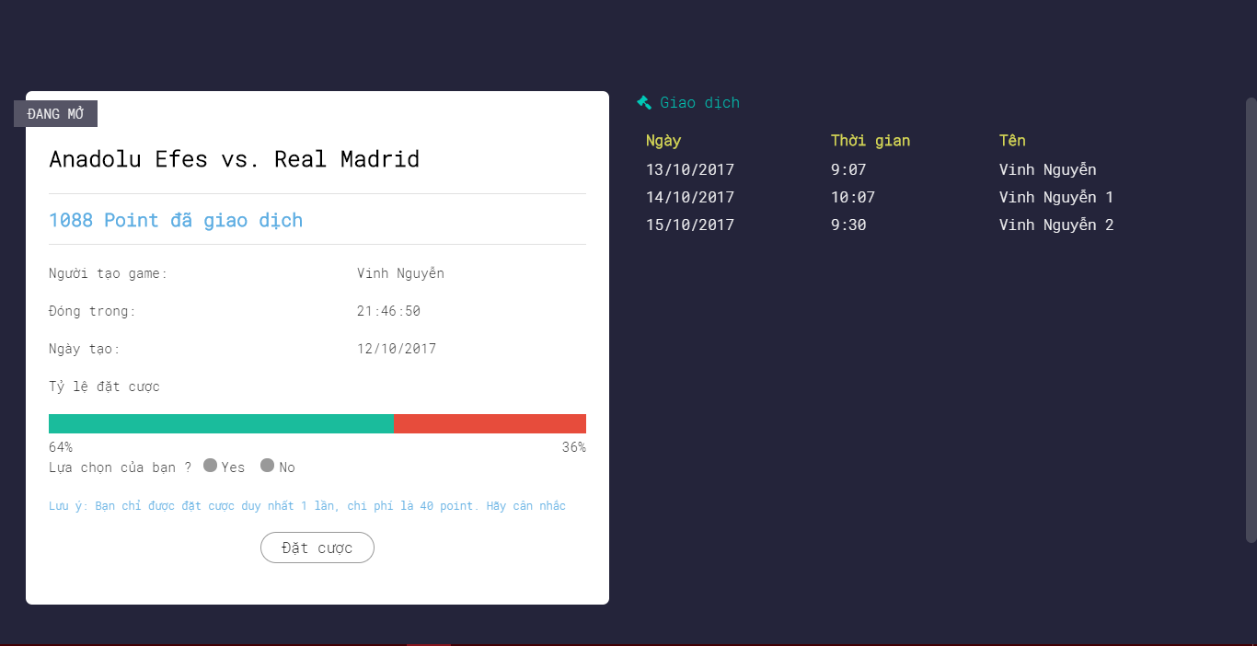

4.7.17. Multiple Choice Game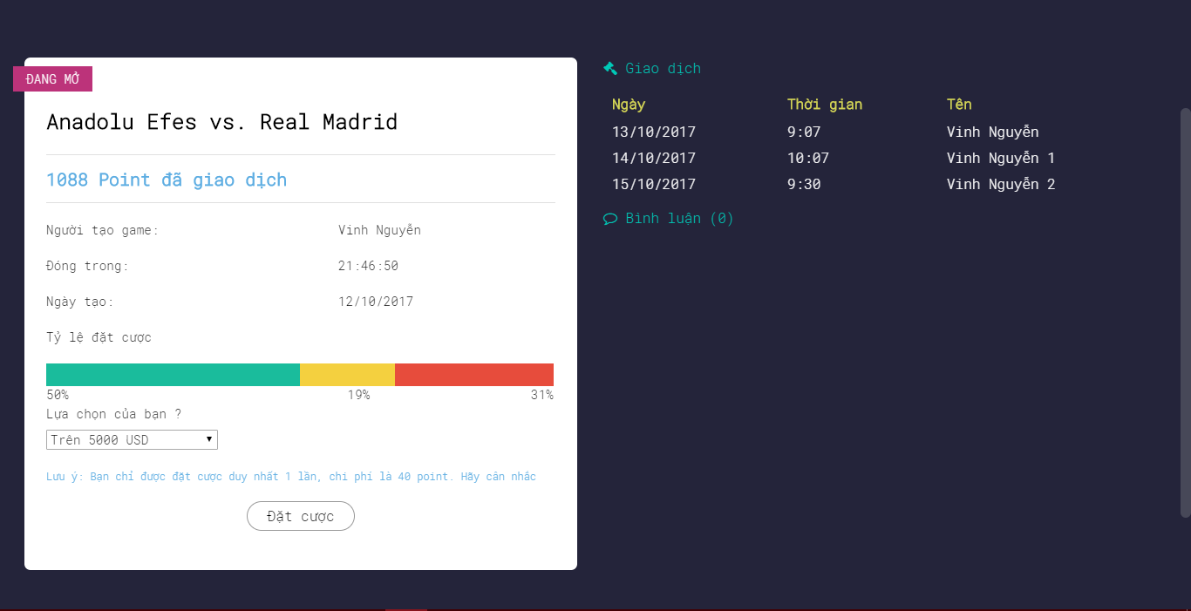

4.8. Database Design

4.8.1. Overview

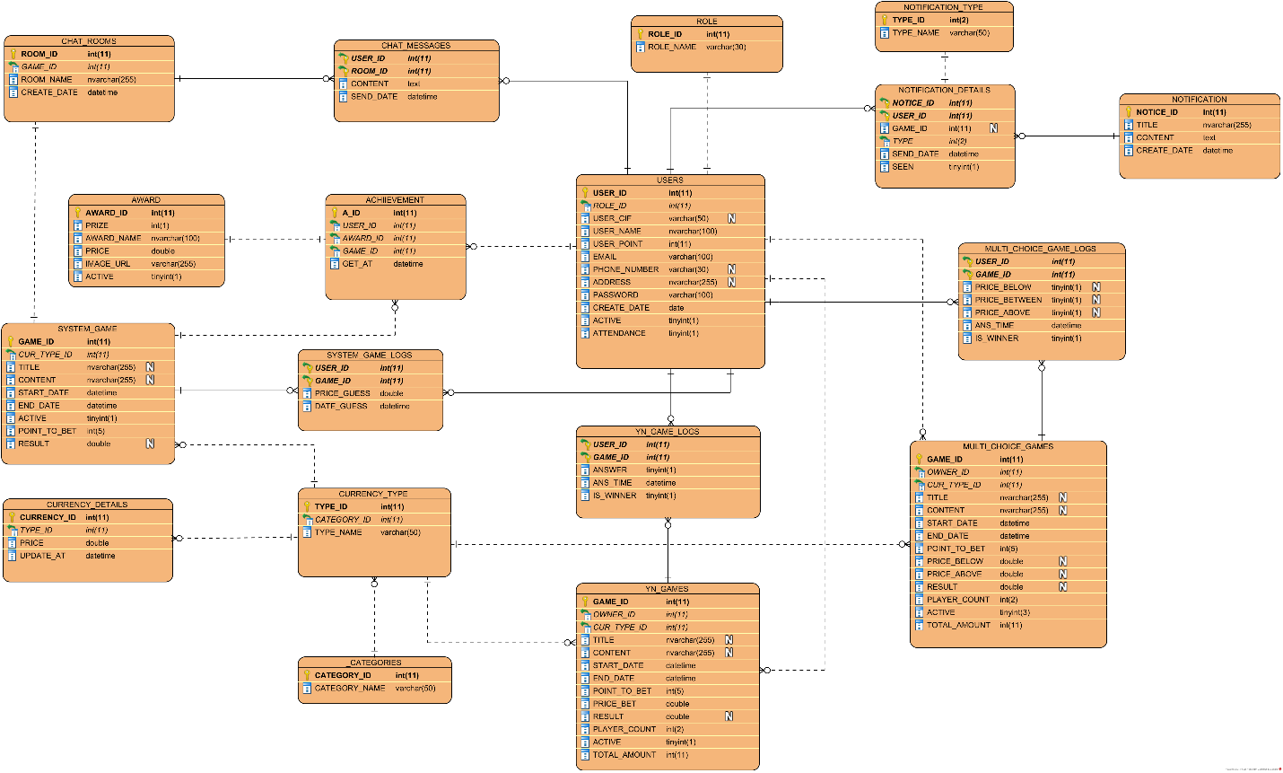

Figure Database Design Screen

4.8.2. ROLE table

ROLE table store users’ role information

|  |  |  |  |  |  |
| --- | --- | --- | --- | --- | --- |
| **No.** | **Field Name** | **Type** | **Size** | **Description** | **Not Null** |
| 1 | ROLE_ID (Primary key) | int | 11 | The unique identity field for role | X |
| 2 | ROLE_NAME | varchar | 30 | Name of the role | X |

4.8.3. USERS table

|  |  |  |  |  |  |
| --- | --- | --- | --- | --- | --- |
| **No.** | **Field Name** | **Type** | **Size** | **Description** | **Not Null** |
| 1 | USER_ID  (Primary key) | int | 11 | The unique identity field for user | X |
| 2 | ROLE_ID | int | 11 | The unique identity field for role  REFERENCES ROLE(ROLE_ID) | X |
| 3 | USER_CIF | varchar | 50 | The user’s id is returned from facebook or google while login with these providers |  |
| 4 | USER_NAME | nvarchar | 100 | Name of user | X |
| 5 | PASSWORD | varchar | 100 | Password to login |  |
| 6 | USER_POINT | int | 11 | The point to join the created by system or users | X |
| 7 | EMAIL | varchar | 100 | Email of user | X |
| 8 | PHONE_NUMBER | varchar | 30 | Phone number of user |  |
| 9 | ADDRESS | nvarchar | 255 | Address of user |  |
| 10 | CREATE_DATE | date |  | The day that user join us | X |
| 11 | ATTENDANCE | bool |  | This field to check if user use service daily | X |
| 12 | ACTIVE | bool |  | To block or active user | X |

4.8.4. NOTIFICATION table

NOTIFICATION table store the message sent to user when necessary

|  |  |  |  |  |  |
| --- | --- | --- | --- | --- | --- |
| **No.** | **Field Name** | **Type** | **Size** | **Description** | **Not Null** |
| 1 | NOTICE_ID  (PRIMARY KEY) | int | 11 | The unique identity field for message | X |
| 2 | TITLE | nvarchar | 255 | Title of message | X |
| 3 | CONTENT | text |  | Content of message | X |
| 4 | CREATE_DATE | datetime |  | Date when message is created | X |

4.8.5. NOTIFICATION_TYPE table

NOTIFICATION_TYPE table store type of notice

|  |  |  |  |  |  |
| --- | --- | --- | --- | --- | --- |
| **No.** | **Field Name** | **Type** | **Size** | **Description** | **Not Null** |
| 1 | TYPE_ID  (PRIMARY KEY) | int | 11 | The unique identity field for message type | X |
| 2 | TYPE_NAME | varchar | 20 | Name of type | X |

4.8.6. NOTIFICATION_DETAILS table

NOTIFICATION_DETAILS table store logs when messages sent to users

|  |  |  |  |  |  |
| --- | --- | --- | --- | --- | --- |
| **No.** | **Field Name** | **Type** | **Size** | **Description** | **Not Null** |
| 1 | NOTICE_ID  references NOTIFICATION(NOTICE_ID) | int | 11 | The unique identity field for message | X |
| 2 | USER_ID  references USERS(USER_ID) | int | 11 | The unique identity field for user | X |
| 3 | TYPE_ID  references NOTIFICATION_TYPE(TYPE_ID) | int | 2 | The unique identity field for type | X |
| 4 | GAME_ID | int | 11 | To determine what game message responsible for | X |
| 5 | SEND_DATE | datetime |  | Date that message was sent to user | X |
| 6 | SEEN | bool |  | Status of message when received by user | X |

4.8.7. CHAT_ROOMS table

CHAT_ROOMS table store the channel that message’s sent to

|  |  |  |  |  |  |
| --- | --- | --- | --- | --- | --- |
| **No.** | **Field Name** | **Type** | **Size** | **Description** | **Not Null** |
| 1 | ROOM_ID  (Primary key) | int | 11 | The unique identity field for channel | X |
| 2 | GAME_ID  references SYSTEM_GAMES (GAME_ID) | int | 11 | Game that chat channel is created for | X |
| 3 | ROOM_NAME | varchar | 100 | The name of channel | X |
| 4 | CREATE_DATE | datetime |  | The day that room is created | X |

4.8.9. CHAT_MESSAGES table

CHAT_MESSAGES table store message that is commented by user to system game

|  |  |  |  |  |  |
| --- | --- | --- | --- | --- | --- |
| **No.** | **Field Name** | **Type** | **Size** | **Description** | **Not Null** |
| 1 | MESSAGE_ID  (Primary key) | int | 11 | The unique identity field for comment | X |
| 2 | USER_ID  references USERS(USER_ID) | int | 11 | The owner of comment | X |
| 3 | ROOM_ID  references CHAT_ROOMS(ROOM_ID) | int | 11 | The channel that comment in | X |
| 4 | CONTENT | nvarchar | 255 | Content of comment | X |
| 5 | SEND_DATE | dateitme |  | Date that user leave their comment | X |

4.8.10. CATEGORIES table

CATEGORIES table store currency category information

|  |  |  |  |  |  |
| --- | --- | --- | --- | --- | --- |
| **No.** | **Field Name** | **Type** | **Size** | **Description** | **Not Null** |
| 1 | CATEGORY_ID  (Primary key) | int | 11 | The unique identity field for category | X |
| 2 | CATEGORY_NAME | varchar | 30 | Category name | X |

4.8.11. CURRENCY_TYPE table

CURRENCY_TYPE table store currency type

|  |  |  |  |  |  |
| --- | --- | --- | --- | --- | --- |
| **No.** | **Field Name** | **Type** | **Size** | **Description** | **Not Null** |
| 1 | TYPE_ID  (Primary key) | int | 11 | The unique identity field for type | X |
| 2 | TYPE_NAME | varchar | 20 | Type name | X |
| 3 | CATEGORY_ID  references CATEGORIES(CATEGORY_ID) | int | 11 | Category of type | X |

4.8.12. CURRENCY_DETAILS table

CURRENCY_DETAILS table store information about a specificed currency unit at a time

|  |  |  |  |  |  |
| --- | --- | --- | --- | --- | --- |
| **No.** | **Field Name** | **Type** | **Size** | **Description** | **Not Null** |
| 1 | CURRENCY_ID  (Primary key) | int | 11 | The unique identity field for currency | X |
| 2 | PRICE | double |  | Price of currency unit at a time | X |
| 3 | UPDATE_AT | datetime |  | The time that currency is to be value at | X |
| 4 | TYPE_ID  references CURRENCY_TYPE(TYPE_ID) | int |  | Type of currency | X |

4.8.13. SYSTEM_GAMES table

SYSTEM_GAMES table store the game automatically created by system

|  |  |  |  |  |  |
| --- | --- | --- | --- | --- | --- |
| **No.** | **Field Name** | **Type** | **Size** | **Description** | **Not Null** |
| 1 | GAME_ID  (Primary key) | int | 11 | The unique identity field for game | X |
| 2 | TITLE | nvarchar | 255 | Game title | X |
| 3 | CONTENT | nvarchar | 255 | Game content | X |
| 4 | START_DATE | datetime |  | Time that game starts | X |
| 5 | END_DATE | datetime |  | Time that game ends | X |
| 6 | ACTIVE | bool |  | Status of game | X |
| 7 | POINT_TO_BET | double |  | Point spent to join game | X |
| 8 | RESULT | double |  | Result of game |  |
| 9 | CUR_TYPE_ID  references CURRENCY_TYPE(TYPE_ID) | int | 11 | Type of game corresponding to type of currency | X |

4.8.14. SYSTEM_GAME_LOGS table

SYSTEM_GAME_LOGS store history of system game

|  |  |  |  |  |  |
| --- | --- | --- | --- | --- | --- |
| **No.** | **Field Name** | **Type** | **Size** | **Description** | **Not Null** |
| 1 | USER_ID  references USERS(USER_ID) | int | 11 | Game’s player | X |
| 2 | GAME_ID  references SYSTEM_GAMES(GAME_ID) | int | 11 | Game that logs belong to | X |
| 3 | PRICE_GUESS | double |  | Value of currency unit user guess | X |
| 4 | DATE_GUESS | datetime |  | Time user leave their prediction | X |

4.8.15. AWARD table

AWARD table store gift for the 3 first prizes of system game

|  |  |  |  |  |  |
| --- | --- | --- | --- | --- | --- |
| **No.** | **Field Name** | **Type** | **Size** | **Description** | **Not Null** |
| 1 | AWARD_ID  (Primary key) | int | 11 | The unique identity field for award | X |
| 2 | PRIZE | int | 1 | The prize that the gift belongs to | X |
| 3 | AWARD_NAME | nvarchar | 100 | Name | X |
| 4 | PRICE | double |  | Value of gift | X |
| 5 | IMAGE_URL | varchar | 255 | Image of gift | X |
| 6 | ACTIVE | bool |  | Status of gift | X |

4.8.16. ACHIEVEMENT table

ACHIEVEMENT table store winners of system game

|  |  |  |  |  |  |
| --- | --- | --- | --- | --- | --- |
| **No.** | **Field Name** | **Type** | **Size** | **Description** | **Not Null** |
| 1 | A_ID | int | 11 | The unique identity field for achievement | X |
| 2 | USER_ID  references USERS(USER_ID) | int | 11 | User get achievement | X |
| 3 | AWARD_ID  references AWARD(AWARD_ID) | int | 11 | The ward for winner | X |
| 4 | GAME_ID  references SYSTEM_GAMES(GAME_ID) | int | 11 | Game that user get achievement | X |
| 5 | GET_AT | datetime |  | Time that user get achievement | X |

4.8.17. YN_GAMES table

YN_GAMES table store binary option game (true/faslse) created by users

|  |  |  |  |  |  |
| --- | --- | --- | --- | --- | --- |
| **No.** | **Field Name** | **Type** | **Size** | **Description** | **Not Null** |
| 1 | GAME_ID  (Primary key) | int | 11 | The unique identify field for game | X |
| 2 | OWNER_ID  references USERS(USER_ID) | int | 11 | The owner of game | X |
| 3 | CUR_TYPE_ID  references CURRENCY_TYPE(TYPE_ID) | int | 11 | The currency unit that game use to bet | X |
| 4 | TITLE | nvarchar | 255 | Game title | X |
| 5 | CONTENT | nvarchar | 255 | Game content | X |
| 6 | START_DATE | datetime |  | Time to start game | X |
| 7 | END_DATE | datetime |  | Time to end game | X |
| 8 | POINT_TO_BET | int | 5 | Point to join game | X |
| 9 | PRICE_BET | double |  | Value of currency unit that user raise to bet | X |
| 10 | RESULT | double |  | Result of game |  |
| 11 | PLAYER_COUNT | int | 2 | Number of players join game.  (<= 40) | X |
| 12 | ACTIVE | bool |  | Status of game. It’s set to false if game end | X |
| 13 | TOTAL_AMOUNT | int | 11 | Total point get from players  (PLAYER_COUNT*POINT_TO_BET) | X |

4.8.18. YN_GAME_LOGS table

YN_GAME_LOGS table store history of yn_game

|  |  |  |  |  |  |
| --- | --- | --- | --- | --- | --- |
| **No.** | **Field Name** | **Type** | **Size** | **Description** | **Not Null** |
| 1 | USER_ID  references USERS(USER_ID) | int | 11 | Players in game | X |
| 2 | GAME_ID  references YN_GAMES(GAME_ID) | int | 11 | The unique identify field for game that log is saved | X |
| 3 | ANSWER | bool |  | The answer players choose | X |
| 4 | ANS_TIME | datetime |  | Date that user join game | X |
| 5 | IS_WINNER | bool |  | Result of game that point out who is winner or looser |  |

4.8.19. MULTI_CHOICE_GAMES table

MULTI_CHOICE_GAMES table store multichoice game created by user

|  |  |  |  |  |  |
| --- | --- | --- | --- | --- | --- |
| **No.** | **Field Name** | **Type** | **Size** | **Description** | **Not Null** |
| 1 | GAME_ID  (Primary key) | int | 11 | The unique identify field for game | X |
| 2 | OWNER_ID | int | 11 | The owner of game | X |
| 3 | CUR_TYPE_ID | int | 11 | The currency unit that game use to bet | X |
| 4 | TITLE | nvarchar | 255 | Game title | X |
| 5 | CONTENT | nvarchar | 255 | Game content | X |
| 6 | START_DATE | datetime |  | Time to start game | X |
| 7 | END_DATE | datetime |  | Time to end game | X |
| 8 | POINT_TO_BET | int | 5 | Point to join game | X |
| 9 | PRICE_BELOW | double |  | Minimum value of currency unit that user raise to bet | X |
| 10 | PRICE_ABOVE | double |  | Maximum value of currency unit that user raise to bet | X |
| 11 | RESULT | double |  | Value of currency unit when game ends |  |
| 12 | PLAYER_COUNT | int | 2 | Number of players join game.  (<= 40) | X |
| 13 | ACTIVE | bool |  | Status of game. It’s set to false if game end | X |
| 14 | TOTAL_AMOUNT | int | 11 | Total point get from players  (PLAYER_COUNT*POINT_TO_BET) |  |

4.8.20. MULTI_CHOICE_GAME_LOGS table

MULTI_CHOICE_GAME_LOGS table store history of multi choice game

|  |  |  |  |  |  |
| --- | --- | --- | --- | --- | --- |
| **No.** | **Field Name** | **Type** | **Size** | **Description** | **Not Null** |
| 1 | USER_ID  references USERS(USER_ID) | int | 11 | Players in game | X |
| 2 | GAME_ID  references YN_GAMES(GAME_ID) | int | 11 | The unique identify field for game that log is saved | X |
| 3 | PRICE_BELOW | bool |  | Option that player choose. True if the real price < MULTI_CHOICE_GAMES (PRICE_BELOW) | X |
| 4 | PRICE_BETWEEN | bool |  | Option that player choose. True if the MULTI_CHOICE_GAMES (PRICE_BELOW) <= real price <= MULTI_CHOICE_GAMES (PRICE_ABOVE) | X |
| 5 | PRICE_ABOVE | bool |  | Option that player choose. True if the real price > MULTI_CHOICE_GAMES (PRICE_ABOVE) | X |
| 6 | ANS_TIME | datetime |  | Date that user join game | X |
| 7 | IS_WINNER | bool |  | Result of game that point out who is winner or looser |  |